Terraform Challenge-03
The final architecture will be:
Internet
|
v
+----------------+
| Application LB |
| Port 80 |
+-------+--------+
|
| HTTP 8080
v
+----------------+
| EC2 Ubuntu |
| Docker Engine |
| Container |
| nginx :8080 |
+----------------+
|
v
Private access
to ECR image

SSH ---> EC2
Only from YOUR_ALLOWED_IP/32

Docker Registry
|
v
ECR
^
|
Terraform pushes local Docker image
Important design choice
We'll use Amazon ECR as the Docker registry.
We'll use:
- VPC — 10.20.0.0/16
- 2 public subnets — for the ALB
- 1 private subnet — for the EC2 application server
- Internet Gateway
- NAT Gateway — so the private EC2 can pull its Docker image from ECR
- Application Load Balancer
- Target Group
- Security Groups
- Ubuntu EC2
- Docker
- Amazon ECR
- SSH key pair
- Terraform provisioner/user-data for Docker deployment
The application itself will listen on 8080, while the ALB listens on 80.Step 1 — Create the project structure
On your Windows machine, open PowerShell: cd C:\Desktop
mkdir terraform-microservice
cd terraform-microservice
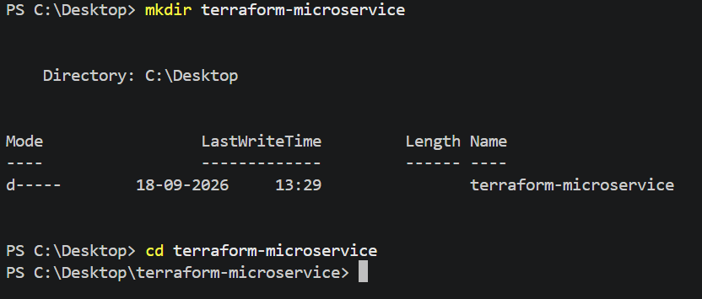
Create this structure:
terraform-microservice/
│
├── main.tf
├── variables.tf
├── outputs.tf
├── providers.tf
├── versions.tf
├── locals.tf
├── terraform.tfvars
├── .gitignore
│
├── Dockerfile
│
├── app/
│ └── index.html
│
├── scripts/
│ ├── user-data.sh
│ └── push-image.ps1
│
└── modules/
├── network/
│ ├── main.tf
│ ├── variables.tf
│ └── outputs.tf
│
├── security/
│ ├── main.tf
│ ├── variables.tf
│ └── outputs.tf
│
├── ecr/
│ ├── main.tf
│ ├── variables.tf
│ └── outputs.tf
│
├── compute/
│ ├── main.tf
│ ├── variables.tf
│ └── outputs.tf
│
└── alb/
├── main.tf
├── variables.tf
└── outputs.tf
Create the directories: mkdir app
mkdir scripts
mkdir modules
mkdir modules\network
mkdir modules\security
mkdir modules\ecr
mkdir modules\compute
mkdir modules\alb
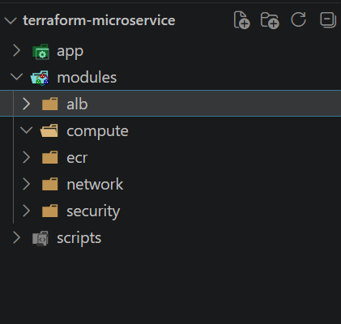

Step 2 — Create the Docker application
Create: Dockerfile
Put this inside: FROM nginx:alpine
COPY app/index.html /usr/share/nginx/html/index.html
RUN sed -i 's/listen 80;/listen 8080;/' /etc/nginx/conf.d/default.conf \
&& sed -i 's/listen \[::\]:80;/listen [::]:8080;/' /etc/nginx/conf.d/default.conf
EXPOSE 8080
CMD ["nginx", "-g", "daemon off;"]
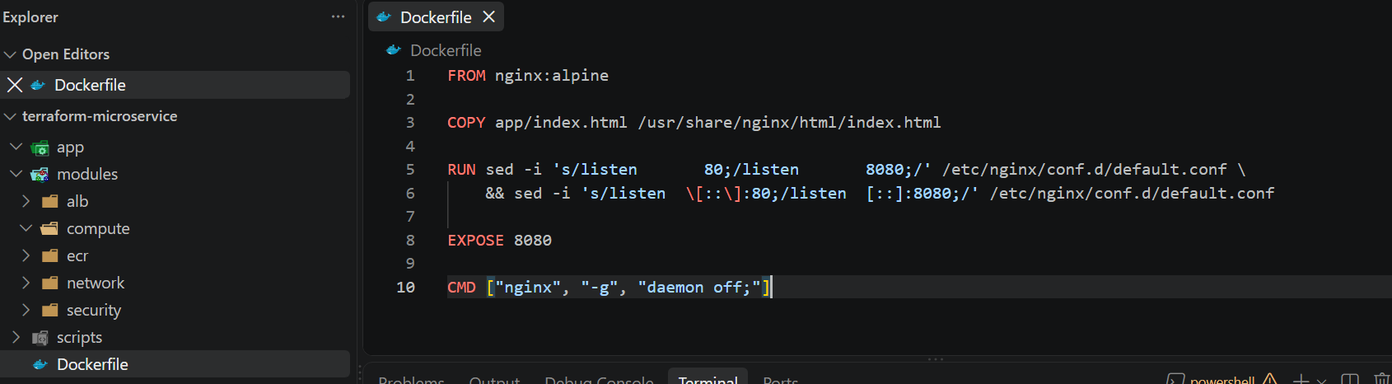
Now create: app/index.html
Use:
<!DOCTYPE html>
<html>
<head>
<title>Terraform Microservice</title>
</head>
<body>
<h1>Hello from Terraform!</h1>
<p>This application is running inside an Nginx Docker container on AWS EC2.</p>
<p>Traffic is received through an Application Load Balancer.</p>
</body>
</html>
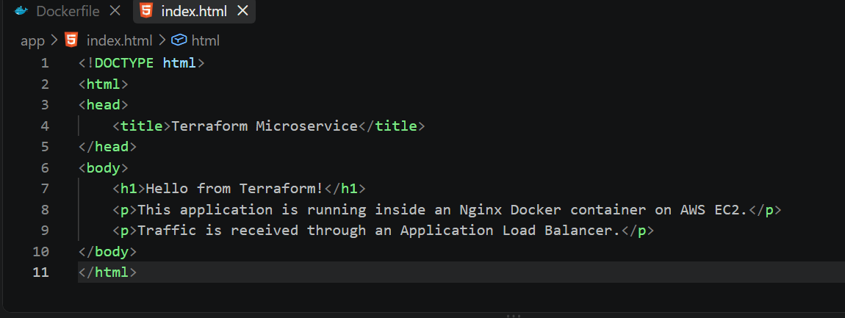

Step 3 — Test Docker locally
Before Terraform touches AWS, test the application locally.
From: cd C:\Desktop\terraform-microservice
Build: docker build -t terraform-microservice:latest .
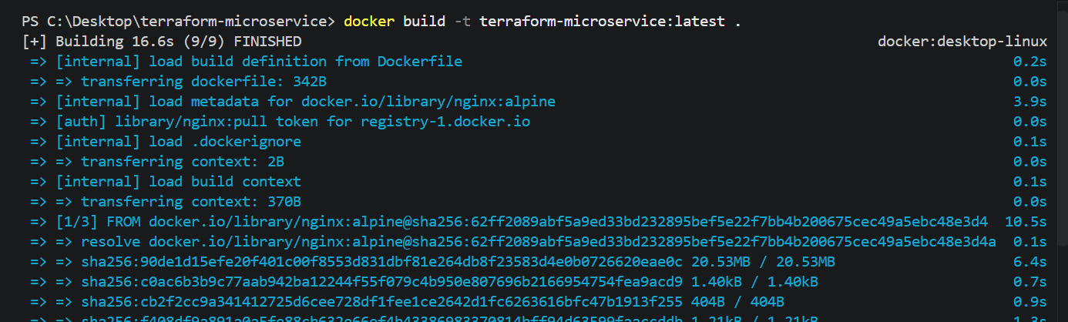
Check: docker images
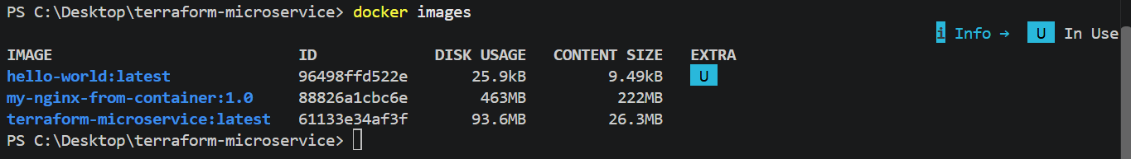
Run: docker run -d --name terraform-microservice -p 8080:8080 terraform-microservice:latest
Check: docker ps
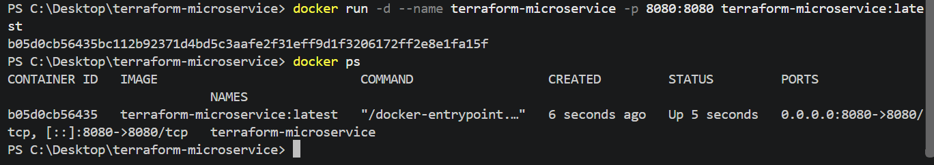
Then open: http://localhost:8080
You should see: Hello from Terraform!
This application is running inside an Nginx Docker container on AWS EC2.
Traffic is received through an Application Load Balancer.
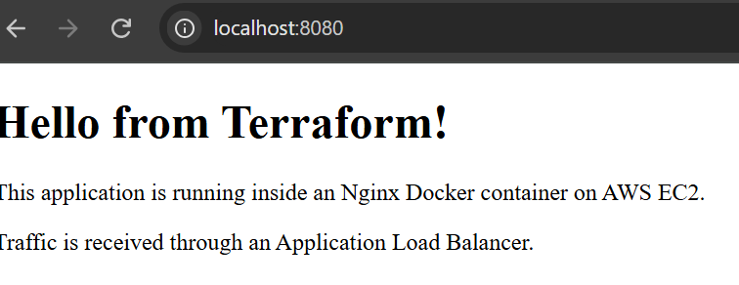
You can also test from PowerShell: curl http://localhost:8080
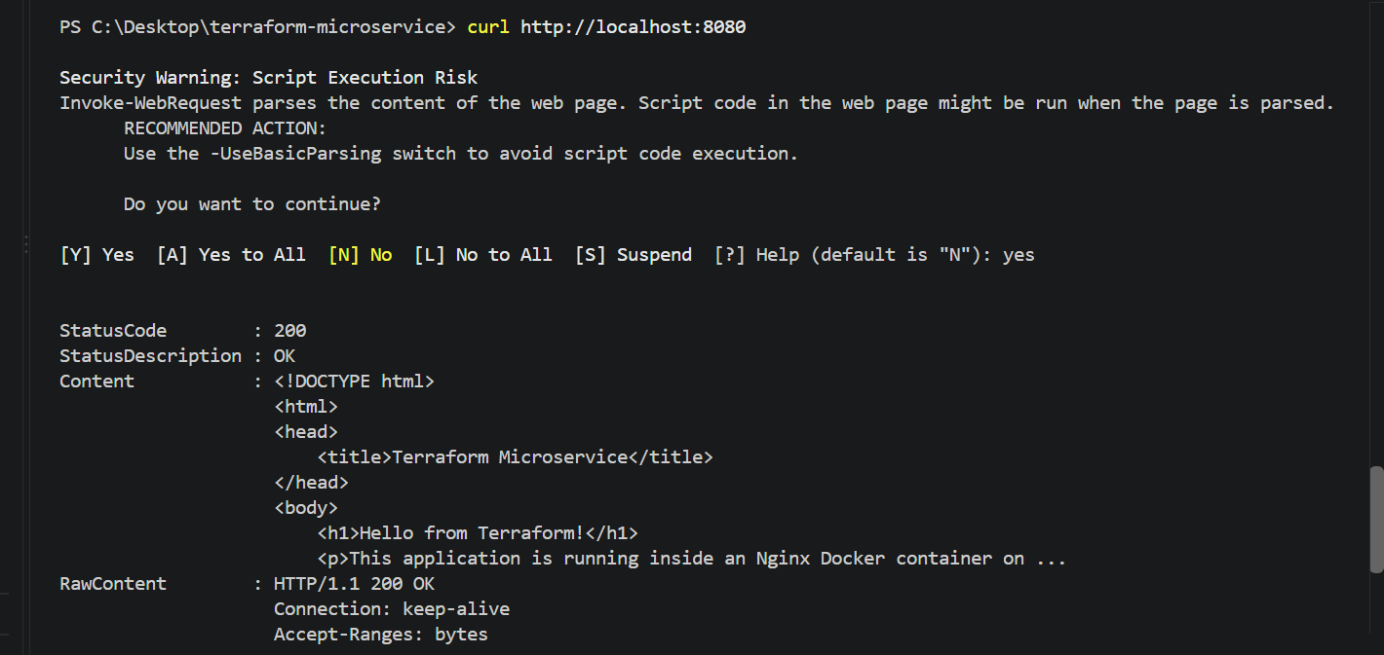

Step 4 — Stop the local container
Once the local test succeeds: docker stop terraform-microservice
Then: docker rm terraform-microservice
Don't delete the image.
We'll use this same local image later for the ECR push.
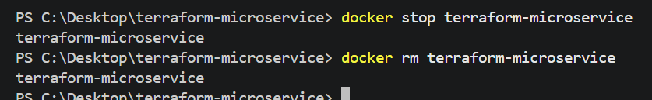Step 5 — Create versions.tf
Create: versions.tf
Use: terraform {
required_version = ">= 1.5.0"
required_providers {
aws = {
source = "hashicorp/aws"
version = "~> 6.0"
}
}
}
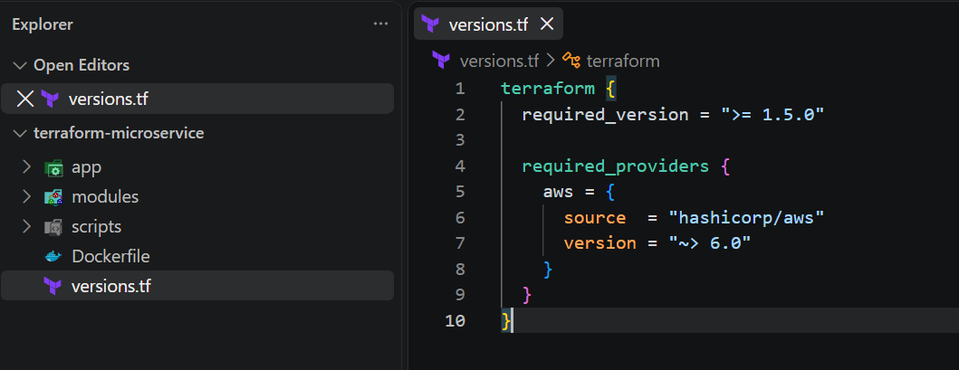

Step 6 — Create providers.tf
provider "aws" {
region = var.aws_region }
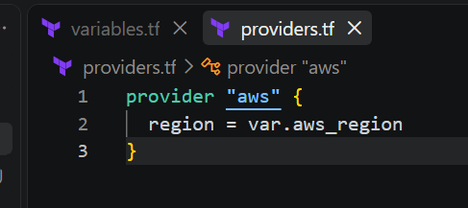Step 7 — Create variables.tf
Create the root: variables.tf
Use: variable "aws_region" { description = "AWS region"
type = string
default = "us-east-1" }
variable "project_name" { description = "Project name"
type = string
default = "terraform-microservice" }
variable "environment" { description = "Environment name"
type = string
default = "dev" }
variable "vpc_cidr" { description = "VPC CIDR"
type = string
default = "10.20.0.0/16" }
variable "allowed_ssh_cidr" { description = "CIDR allowed to SSH into EC2"
type = string }
variable "key_name" { description = "AWS EC2 key pair name"
type = string }
variable "public_key_path" { description = "Path to the public SSH key"
type = string }
variable "ubuntu_ami" { description = "Ubuntu AMI ID"
type = string }
variable "instance_type" { description = "EC2 instance type"
type = string
default = "t3.micro" }
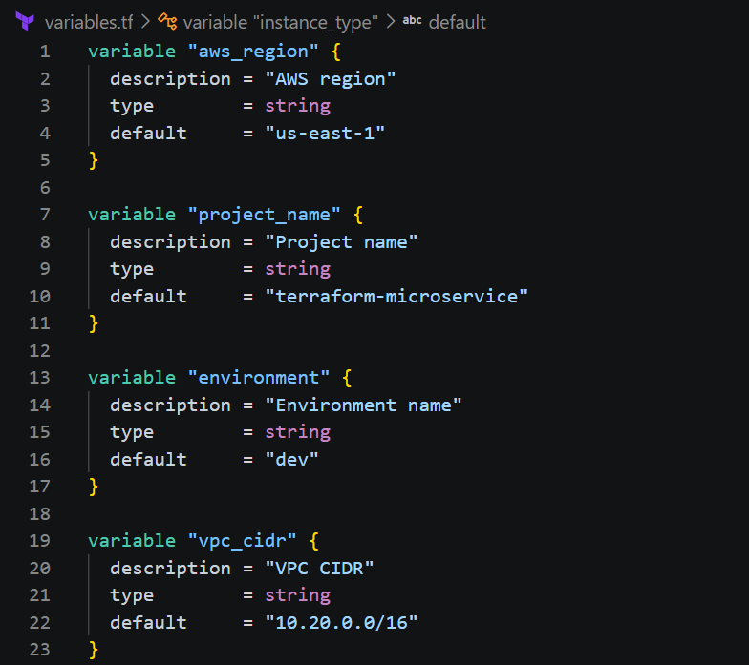
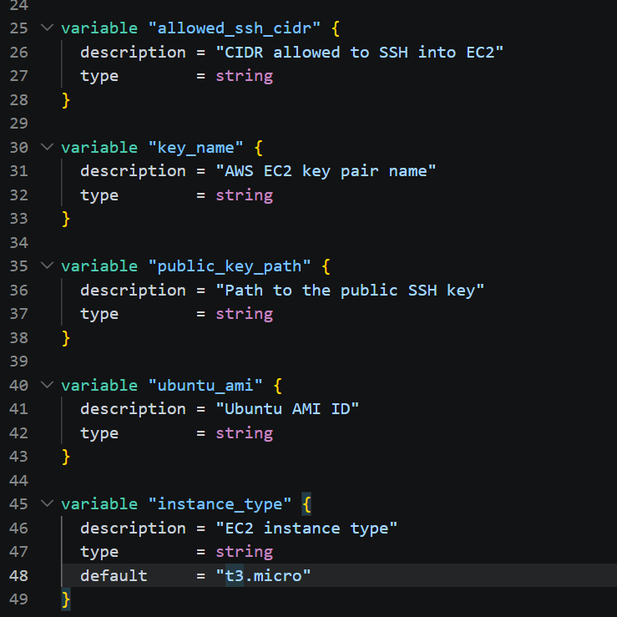
Step 8 — Create terraform.tfvars
This is where we'll put environment-specific values.
aws_region = "us-east-1"
project_name = "terraform-microservice"
environment = "dev"
vpc_cidr = "10.20.0.0/16"
key_name = "terraform-microservice-key"
public_key_path = "C:/Users/YOUR_USERNAME/.ssh/terraform-microservice.pub"
ubuntu_ami = "ami-0b6d9d3d33ba97d99"
allowed_ssh_cidr = "YOUR_PUBLIC_IP/32"
Don't use the example values literally
For: YOUR_USERNAME
use your Windows username.
For: YOUR_PUBLIC_IP/32
use your actual public IP.
For example, if your public IP is: 49.205.100.25
then: allowed_ssh_cidr = "49.205.100.25/32"
The /32 is important because it permits SSH from that single IPv4 address.
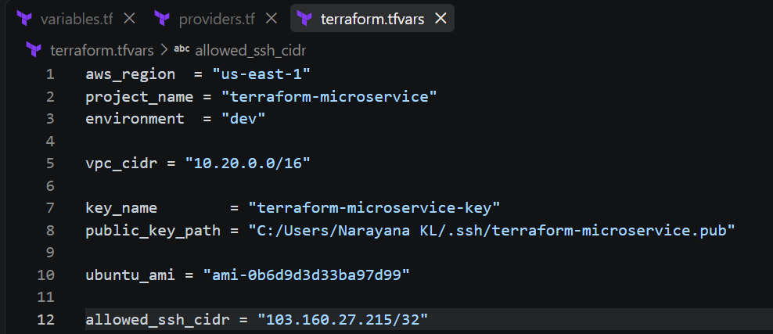

Step 9 — Create the SSH key locally
Because the requirement specifically says to use a locally created key, let's create one.
In PowerShell: mkdir $HOME\.ssh -ErrorAction SilentlyContinue
Then: ssh-keygen -t ed25519 -f $HOME\.ssh\terraform-microservice
When prompted for a passphrase, you can enter one or press Enter for no passphrase.
You should get: terraform-microservice
terraform-microservice.pub
Check: dir $HOME\.ssh\terraform-microservice*
You should see both files.
Your private key: terraform-microservice
Your public key: terraform-microservice.pub
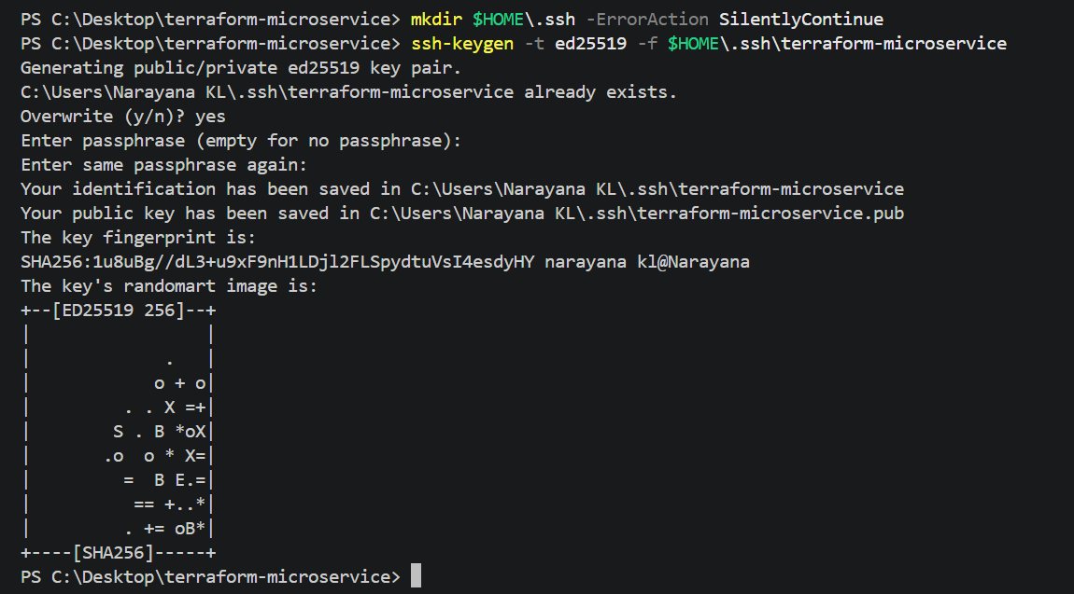
Never commit the private key to Git.Step 10 — Get your public IP
Run: (Invoke-WebRequest -UseBasicParsing https://checkip.amazonaws.com).Content
Suppose it returns:
49.205.100.25
Then update: allowed_ssh_cidr = "49.205.100.25/32"
Also change: public_key_path = "C:/Users/YOUR_USERNAME/.ssh/terraform-microservice.pub"
to your actual Windows path.
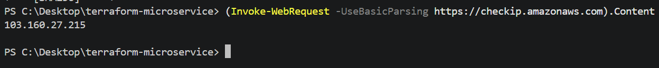
Step 11 — Create .gitignore
Create: .gitignore
Use: .terraform/
*.tfstate
*.tfstate.*
crash.log
crash.*.log
*.tfvars
!example.tfvars
*.pem
*.key
.ssh/
terraform.tfplan
tfplan
*.exe
This protects things such as: terraform.tfstate
terraform.tfvars
private keys
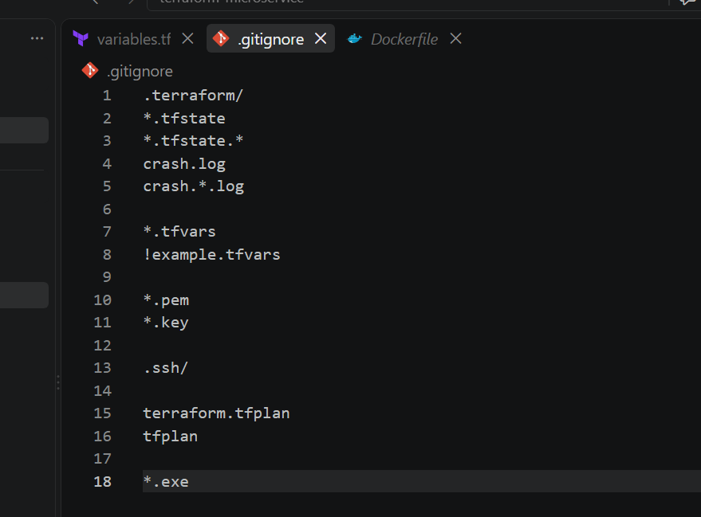
Phase 2 — VPC and Networking
We'll create:
Internet
|
Internet Gateway
|
+--------+--------+
| VPC |
| 10.20.0.0/16 |
| |
+------+-------+ +------+-------+
| Public-A | | Public-B |
| 10.20.1.0/24| |10.20.2.0/24 |
| ALB | | ALB |
+-------------+ +-------------+
|
NAT Gateway
|
+--------+--------+
| Private-A |
| 10.20.10.0/24 |
| EC2 |
+-----------------+
For this exercise, we'll keep the EC2 in a private subnet so it cannot be reached directly from the Internet.

Step 12 — Create the network module
Go to: cd C:\Desktop\terraform-microservice
Create: modules\network\variables.tf
Add: variable "project_name" { description = "Project name"
type = string }
variable "environment" { description = "Environment name"
type = string }
variable "vpc_cidr" { description = "VPC CIDR block"
type = string }
variable "availability_zones" { description = "Availability zones"
type = list(string) }
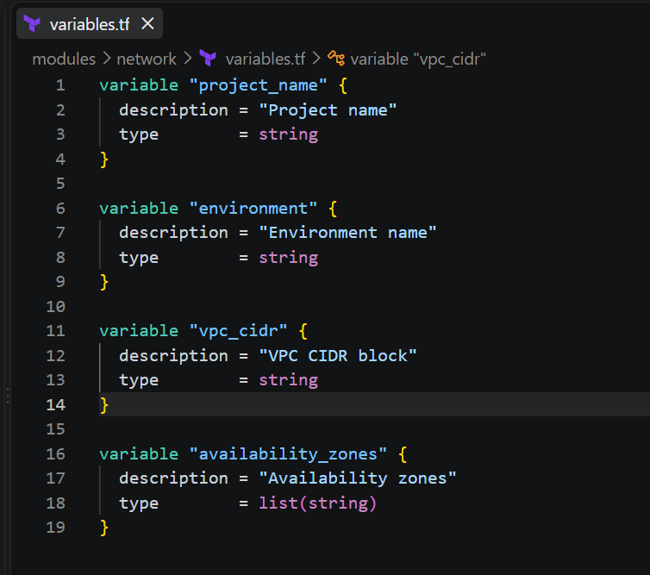
Step 13 — Network module main.tf
Create: modules\network\main.tf
Add: resource "aws_vpc" "this" {
cidr_block = var.vpc_cidr
enable_dns_support = true
enable_dns_hostnames = true
tags = { Name = "${var.project_name}-vpc"
Environment = var.environment
}
}
resource "aws_internet_gateway" "this" {
vpc_id = aws_vpc.this.id
tags = { Name = "${var.project_name}-igw"
Environment = var.environment
}
}
resource "aws_subnet" "public" {
count = length(var.availability_zones)
vpc_id = aws_vpc.this.id
cidr_block = "10.20.${count.index + 1}.0/24"
availability_zone = var.availability_zones[count.index]
map_public_ip_on_launch = true
tags = {
Name = "${var.project_name}-public-${count.index + 1}"
Environment = var.environment
Tier = "public"
}
}
resource "aws_subnet" "private" {
count = 1
vpc_id = aws_vpc.this.id
cidr_block = "10.20.10.0/24"
availability_zone = var.availability_zones[0]
tags = { Name = "${var.project_name}-private-${count.index + 1}"
Environment = var.environment
Tier = "private"
}
}
resource "aws_route_table" "public" {
vpc_id = aws_vpc.this.id
route {
cidr_block = "0.0.0.0/0"
gateway_id = aws_internet_gateway.this.id }
tags = {
Name = "${var.project_name}-public-rt"
Environment = var.environment
}
}
resource "aws_route_table_association" "public" {
count = length(aws_subnet.public)
subnet_id = aws_subnet.public[count.index].id
route_table_id = aws_route_table.public.id }
resource "aws_eip" "nat" {
domain = "vpc"
tags = {
Name = "${var.project_name}-nat-eip"
Environment = var.environment
}
}
resource "aws_nat_gateway" "this" {
allocation_id = aws_eip.nat.id
subnet_id = aws_subnet.public[0].id
depends_on = [
aws_internet_gateway.this
]
tags = {
Name = "${var.project_name}-nat"
Environment = var.environment
}
}
resource "aws_route_table" "private" {
vpc_id = aws_vpc.this.id
route {
cidr_block = "0.0.0.0/0"
nat_gateway_id = aws_nat_gateway.this.id
}
tags = {
Name = "${var.project_name}-private-rt"
Environment = var.environment
}
}
resource "aws_route_table_association" "private" {
subnet_id = aws_subnet.private[0].id
route_table_id = aws_route_table.private.id
}
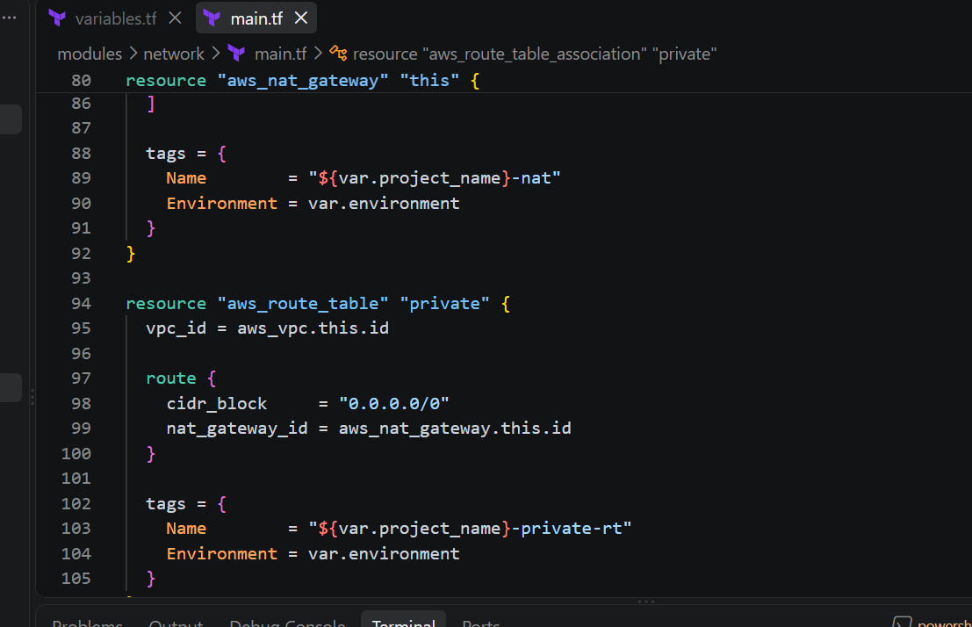

Step 14 — Network module outputs
Create: modules\network\outputs.tf
Add: output "vpc_id" {
description = "VPC ID"
value = aws_vpc.this.id
}
output "vpc_cidr" {
description = "VPC CIDR"
value = aws_vpc.this.cidr_block
}
output "public_subnet_ids" {
description = "Public subnet IDs"
value = aws_subnet.public[*].id
}
output "private_subnet_ids" {
description = "Private subnet IDs"
value = aws_subnet.private[*].id
}
output "availability_zones" {
description = "Availability zones"
value = var.availability_zones
}
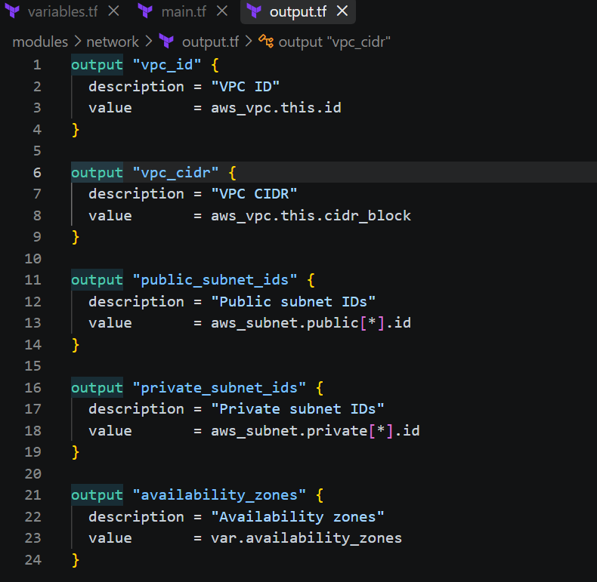

Step 15 — Add the network module to root main.tf
Create/update: main.tf
For now use: locals {
availability_zones = [
"us-east-1a",
"us-east-1b"
]
}
module "network" {
source = "./modules/network"
project_name = var.project_name
environment = var.environment
vpc_cidr = var.vpc_cidr
availability_zones = local.availability_zones
}
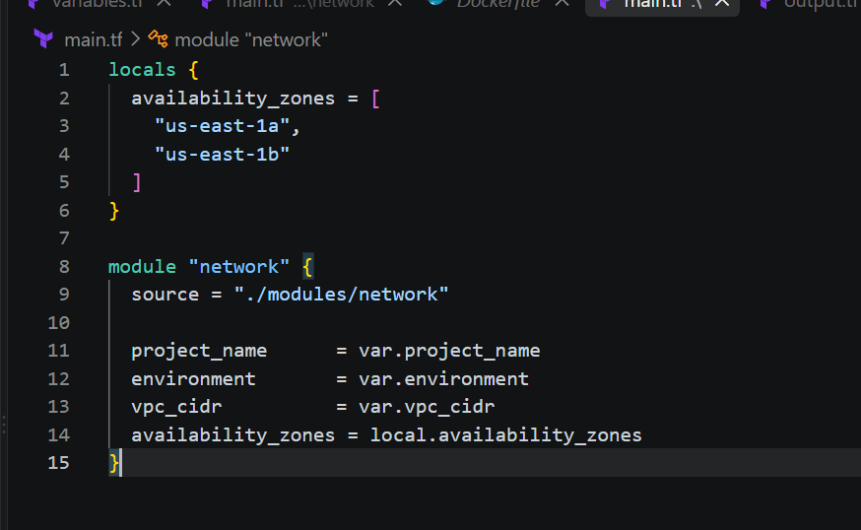Step 16 — Format the code
Run: terraform fmt -recursive
You should see Terraform formatting the module files.
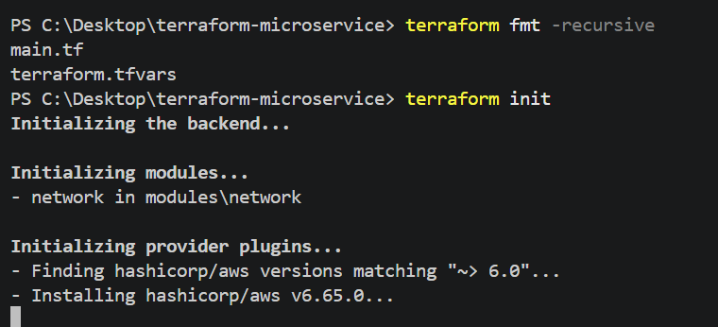

Step 17 — Initialize Terraform
Run: terraform init
You should see something similar to: Initializing the backend...
Initializing modules...
- network in modules/network
Initializing provider plugins...
- Finding hashicorp/aws versions matching "~> 6.0"...
- Installing hashicorp/aws...
Terraform has been successfully initialized!
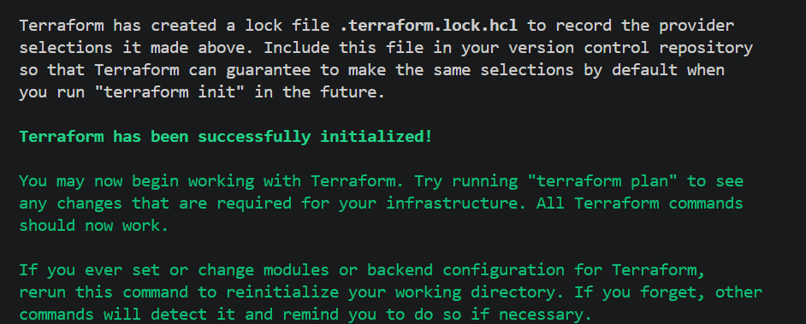Step 18 — Validate
Run: terraform validate
Expected:Success! The configuration is valid. 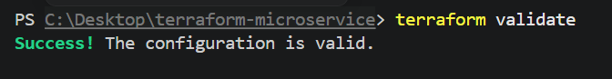Step 19 — Plan the network
Run: terraform plan
At this stage Terraform should plan approximately:
aws_vpc
aws_internet_gateway
aws_subnet.public[0]
aws_subnet.public[1]
aws_subnet.private[0]
aws_route_table.public
aws_route_table_association.public[0]
aws_route_table_association.public[1]
aws_eip.nat
aws_nat_gateway
aws_route_table.private
aws_route_table_association.private
That's roughly 12 resources.
Important Do not run terraform apply yet.
We are building the infrastructure in layers so that if something fails, we know exactly which component caused it.
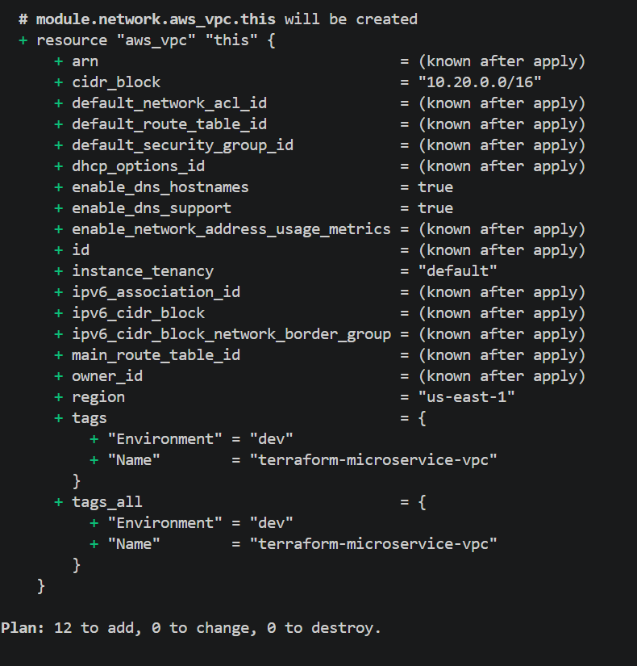

Step 20 — Check your AWS identity
Before creating the infrastructure, run: aws sts get-caller-identity
You should get something like:
{ "UserId": "...",
"Account": "...",
"Arn": "..." }
Also verify your configured region: aws configure get region
It doesn't have to be us-east-1 because Terraform explicitly uses:
aws_region = "us-east-1"
But we'll use us-east-1 throughout this lab.
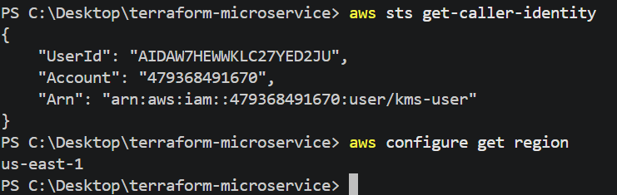
Now we'll create the Amazon ECR Docker registry and prepare Terraform to push your already-tested local Docker image.
Phase 3 — Amazon ECR
Our flow will be:
Local machine
|
| terraform-microservice:latest
v
Amazon ECR
|
| later
v
Private EC2
|
v
Docker container
|
v
Nginx :8080
We will not make ECR public.Step 21 — Create the ECR module
Create: modules\ecr\variables.tf
Add: variable "repository_name" {
description = "ECR repository name"
type = string
}
variable "environment" {
description = "Environment name"
type = string
}
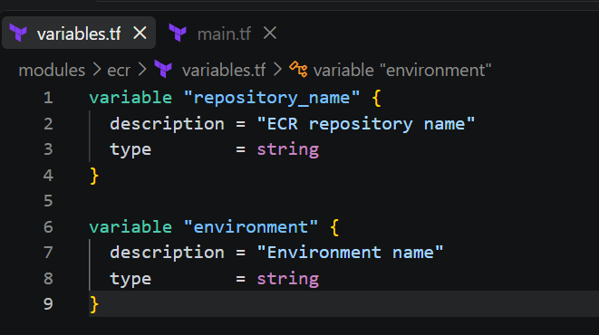
Step 22 — Create ECR main.tf
Create: modules\ecr\main.tf
Add: resource "aws_ecr_repository" "this" {
name = var.repository_name
image_tag_mutability = "MUTABLE"
image_scanning_configuration { scan_on_push = true }
encryption_configuration {
encryption_type = "AES256" }
tags = { Name = var.repository_name
Environment = var.environment }
}
This gives us:
- Private ECR repository
- Mutable tags
- Image scanning on push
- AES-256 encryption
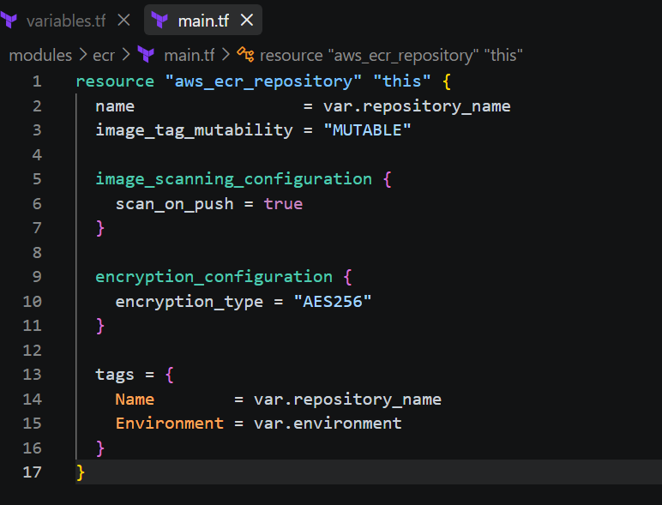

Step 23 — ECR lifecycle policy
Create: modules\ecr\lifecycle.tf
Add: resource "aws_ecr_lifecycle_policy" "this" {
repository = aws_ecr_repository.this.name
policy = jsonencode({
rules = [
{ rulePriority = 1
description = "Keep only the latest 5 images"
selection = {
tagStatus = "any"
countType = "imageCountMoreThan"
countNumber = 5 }
action = {
type = "expire" } } ] })
}
This prevents old images from accumulating indefinitely.
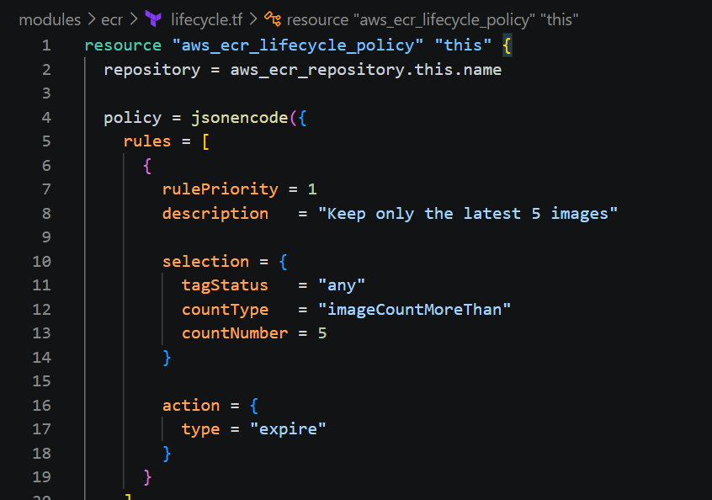

Step 24 — ECR outputs
Create: modules\ecr\outputs.tf
Add: output "repository_name" {
description = "ECR repository name"
value = aws_ecr_repository.this.name
}
output "repository_url" {
description = "ECR repository URL"
value = aws_ecr_repository.this.repository_url
}
output "repository_arn" {
description = "ECR repository ARN"
value = aws_ecr_repository.this.arn
}
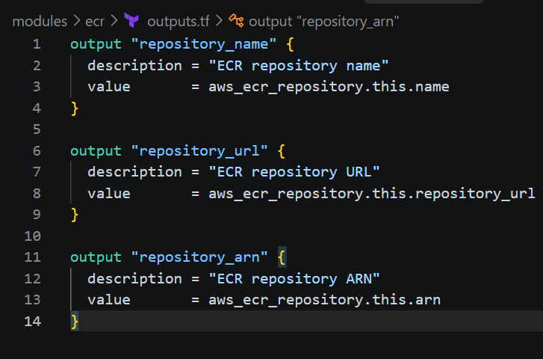

Step 25 — Add ECR module to root
Open: main.tf
Add below the network module:
module "ecr" {
source = "./modules/ecr"
repository_name = "${var.project_name}-${var.environment}"
environment = var.environment
}
Your root main.tf should now look like:
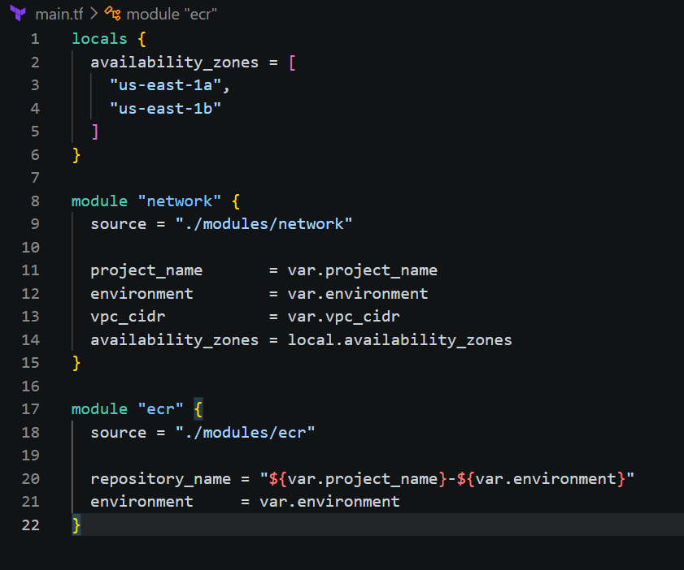Step 26 — Add root outputs
Open: outputs.tf
Add:output "vpc_id" {
description = "VPC ID"
value = module.network.vpc_id }
output "public_subnet_ids" {
description = "Public subnet IDs"
value = module.network.public_subnet_ids }
output "private_subnet_ids" {
description = "Private subnet IDs"
value = module.network.private_subnet_ids
}
output "ecr_repository_url" {
description = "ECR repository URL"
value = module.ecr.repository_url
}
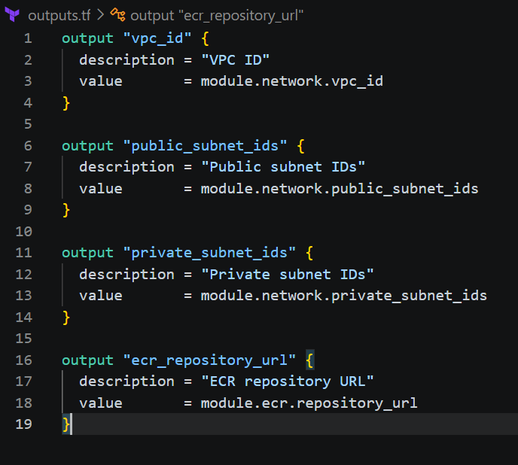Step 27 — Format and validate
Run: terraform fmt -recursive
Then: terraform validate
Expected: Success! The configuration is valid.
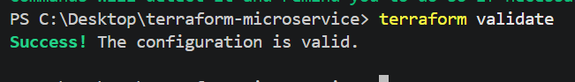
Step 28 — Plan ECR
Run: terraform plan
You should now see the network resources plus:
module.ecr.aws_ecr_repository.this
module.ecr.aws_ecr_lifecycle_policy.this
The important part is that Terraform understands: module.ecr
as a separate reusable component.
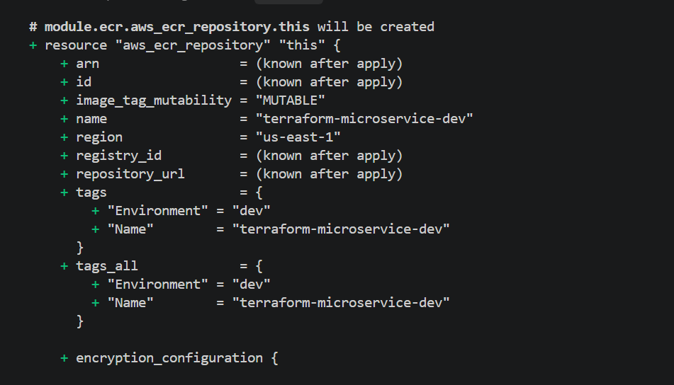
Step 29 — Apply the infrastructure
Now we can create the VPC and ECR.
Run: terraform apply
Terraform will ask: Do you want to perform these actions?
Terraform will perform the actions described above.
Enter a value:
Enter: yes
Wait for it to finish.
You should eventually get something similar to:
Apply complete! Resources: 14 added, 0 changed, 0 destroyed.
Outputs:
ecr_repository_url = "123456789012.dkr.ecr.us-east-1.amazonaws.com/terraform-microservice-dev"
private_subnet_ids = [
"subnet-xxxxxxxx", ]
public_subnet_ids = [
"subnet-xxxxxxxx",
"subnet-yyyyyyyy", ]
vpc_id = "vpc-xxxxxxxx"
Your actual IDs will obviously be different.
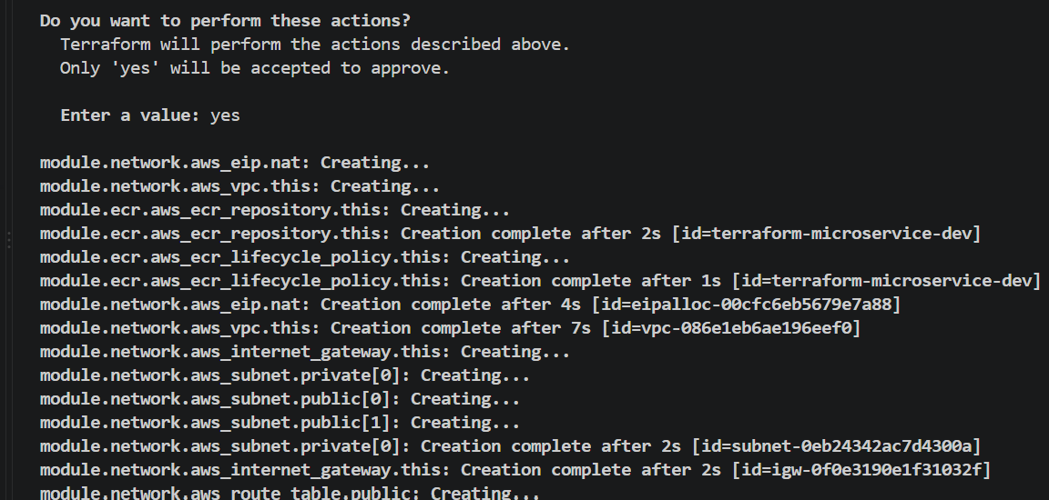
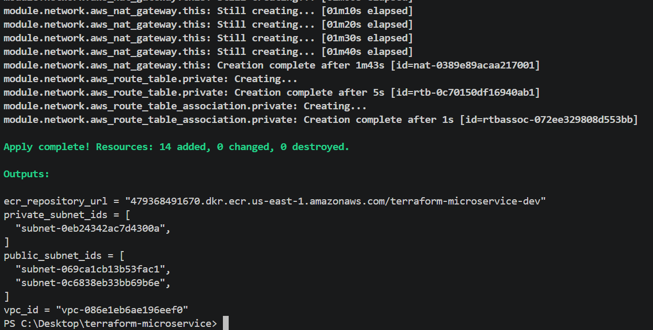

Step 30 — Verify ECR
Run: aws ecr describe-repositories `
--repository-names terraform-microservice-dev `
--region us-east-1
You should see the repository.
You can also run: aws ecr describe-repositories `
--repository-names terraform-microservice-dev `
--region us-east-1 `
--query "repositories[0].repositoryUri" `
--output text
Expected format: 123456789012.dkr.ecr.us-east-1.amazonaws.com/terraform-microservice-dev
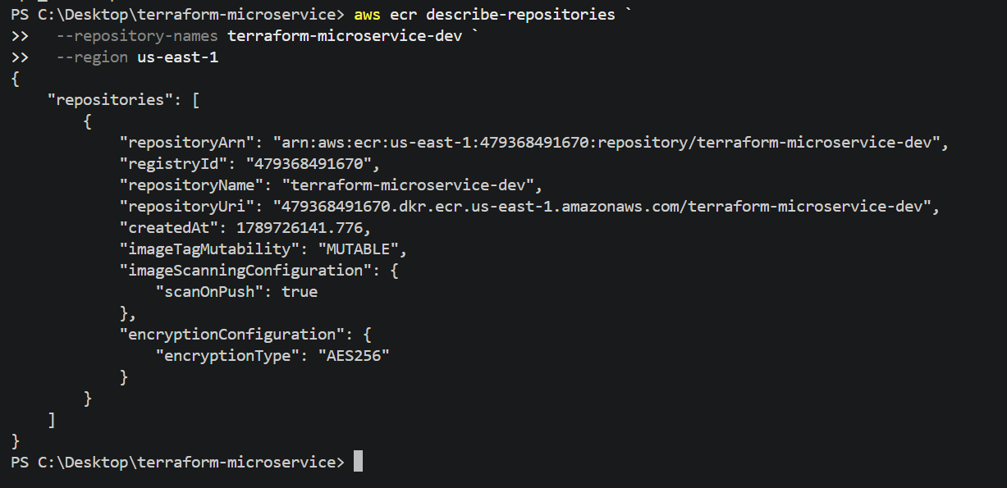

Step 31 — Important: Don't manually push yet
The challenge specifically says:Once the image registry is created, use Terraform to push the local image to the registry.
So don't use the normal manual workflow:
docker login
docker tag
docker push
yet.
Instead, we're going to make Terraform perform the Docker push.
There is an important distinction here:
Terraform
|
+-- AWS provider
| |
| +-- creates ECR
|
+-- Docker provider
|
+-- builds/uses local image
+-- authenticates to ECR
+-- pushes image
For that we'll add the Docker provider to Terraform.

Step 32 — Add Docker provider
Update versions.tf:
terraform {
required_version = ">= 1.5.0"

required_providers {
aws = { source = "hashicorp/aws"
version = "~> 6.0"
}
docker = { source = "kreuzwerker/docker"
version = "~> 3.6" } }
}
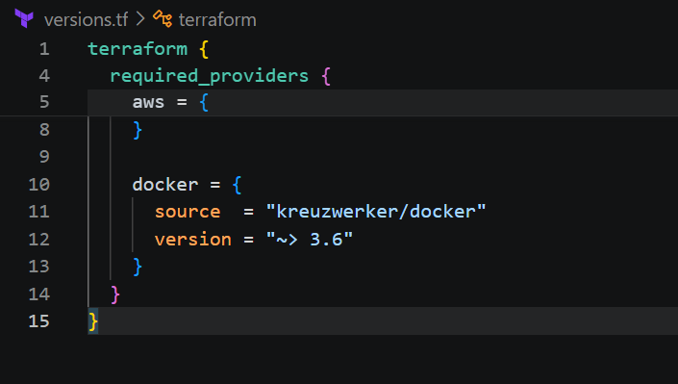
Then update providers.tf: provider "aws" {
region = var.aws_region }
provider "docker" {
}
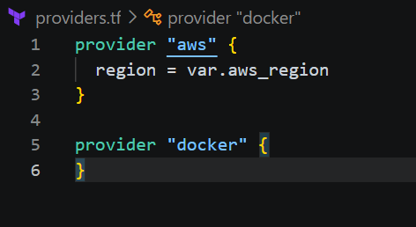
Step 33 — Initialize the Docker provider
Run: terraform init
You should see Terraform downloading: kreuzwerker/docker
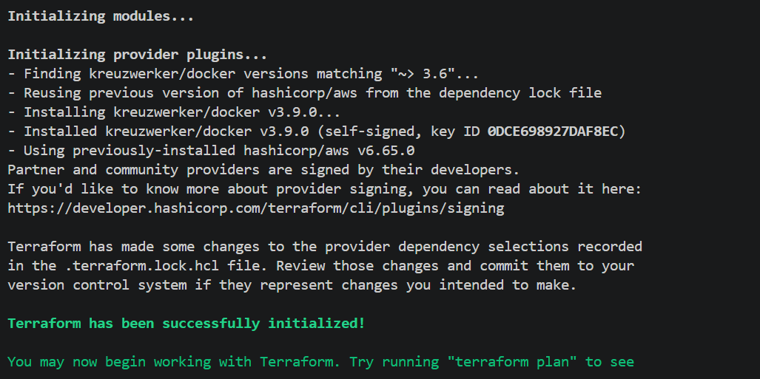
Then: terraform validate
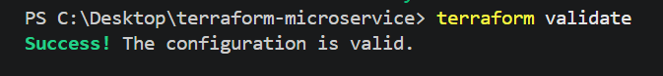
Step 34 — Before pushing, verify your local image
Run: docker images
You should still have: terraform-microservice latest
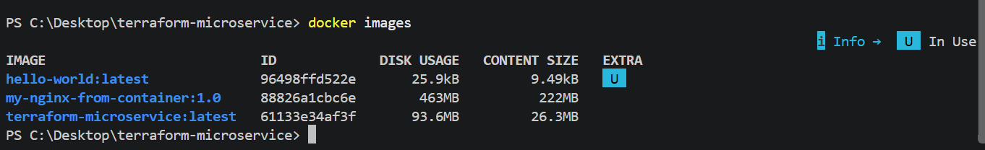
Then: docker inspect terraform-microservice:latest
If that image exists, we're ready.
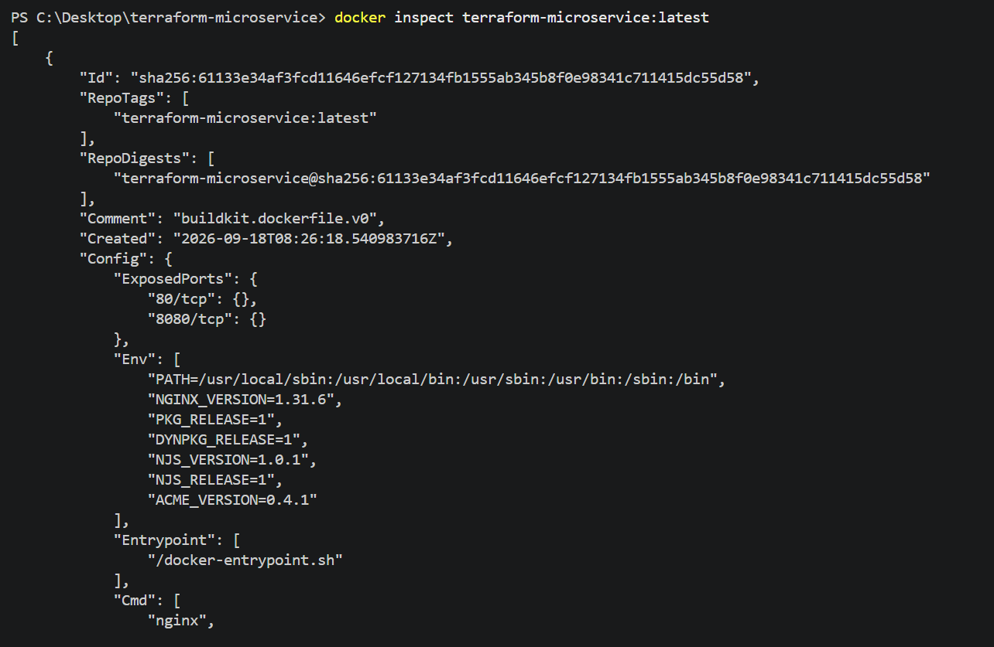

Phase 3B — Terraform pushes the Docker image to ECR
The flow will be: Local Docker image
terraform-microservice:latest
|
| Terraform Docker provider
v
Amazon ECR
|
| later
v
Private EC2
We will not manually run docker push.

Step 33 — Add ECR authentication
Open the root main.tf.
Add this above the modules: data "aws_ecr_authorization_token" "token" {}
So your main.tf should now start approximately like this:
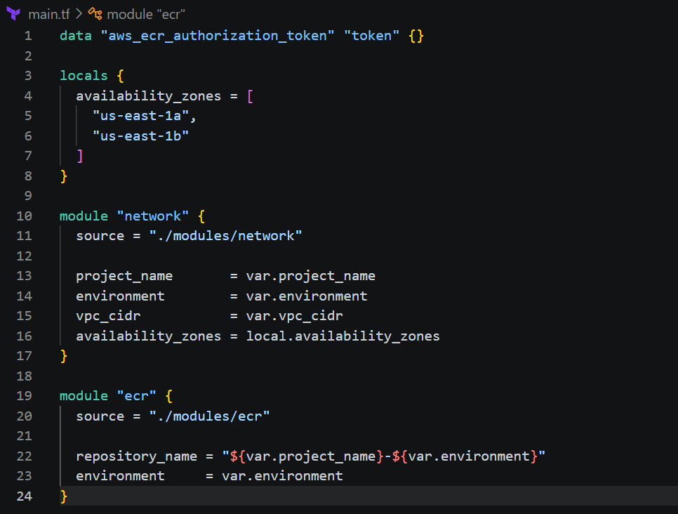
Step 34 — Configure Docker provider authentication
Open: providers.tf
Change it to: provider "aws" {
region = var.aws_region
}
provider "docker" {
registry_auth {
address = data.aws_ecr_authorization_token.token.proxy_endpoint
username = data.aws_ecr_authorization_token.token.user_name
password = data.aws_ecr_authorization_token.token.password
}
}
The AWS provider obtains a temporary ECR authentication token.
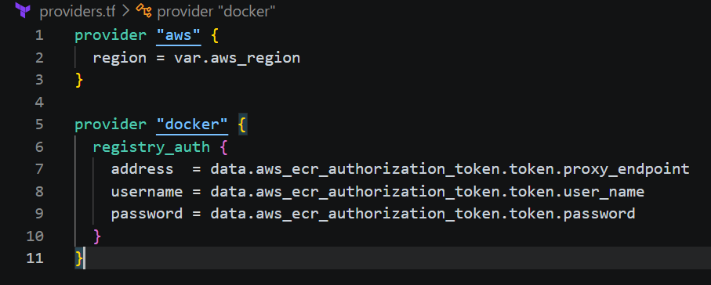
Terraform then passes that authentication to the Docker provider.

Step 35 — Create the Docker image resource
Create: modules\ecr\image.tf
Add: resource "docker_image" "app" {
name = "terraform-microservice:latest"
keep_locally = true
}
Why are we doing this?
The image already exists locally because we built it during Phase 1:
terraform-microservice:latest
This resource tells Terraform:
"Use this existing local Docker image."
We are not rebuilding the image with Terraform.
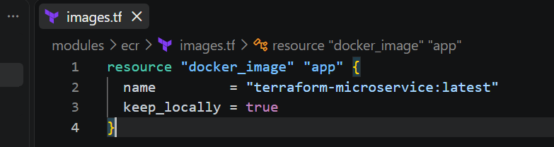

Step 36 — Push the image to ECR
Add the following to:
modules\ecr\image.tf
resource "docker_registry_image" "app" {
name = "${aws_ecr_repository.this.repository_url}:latest"

keep_remotely = true

triggers = {
local_image = docker_image.app.repo_digest
}
}
Your complete modules\ecr\image.tf should now be:
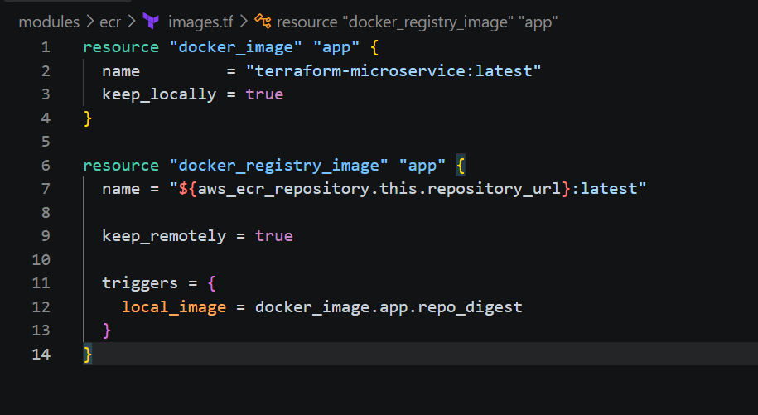

Step 37 — Add ECR image output
Open: modules\ecr\outputs.tf
Add: output "image_uri" {
description = "Docker image URI"
value = docker_registry_image.app.name
}
So you now have:
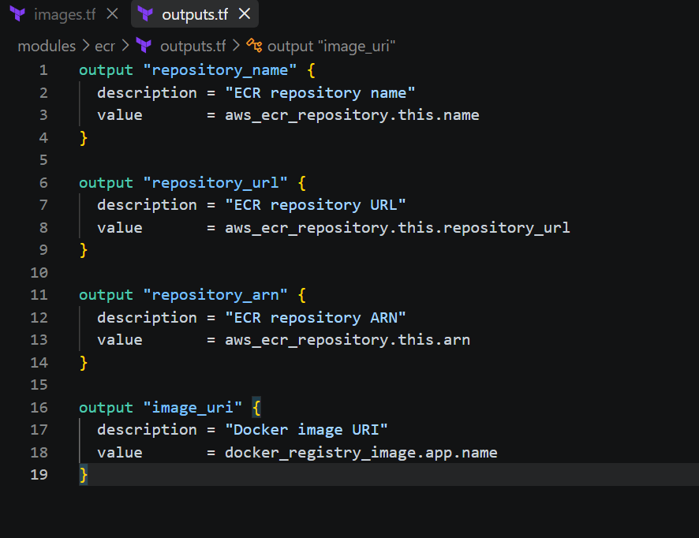
Step 38 — Add root image output
Open: outputs.tf
Add: output "ecr_image_uri" {
description = "ECR Docker image URI"
value = module.ecr.image_uri
}
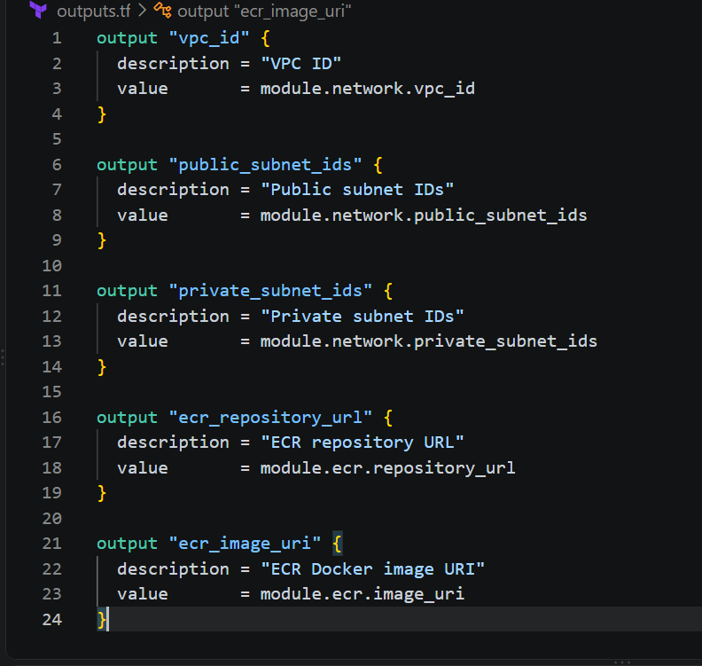Step 39 — Format and validate
Run: terraform fmt -recursive
Then: terraform validate
Expected: Success! The configuration is valid.
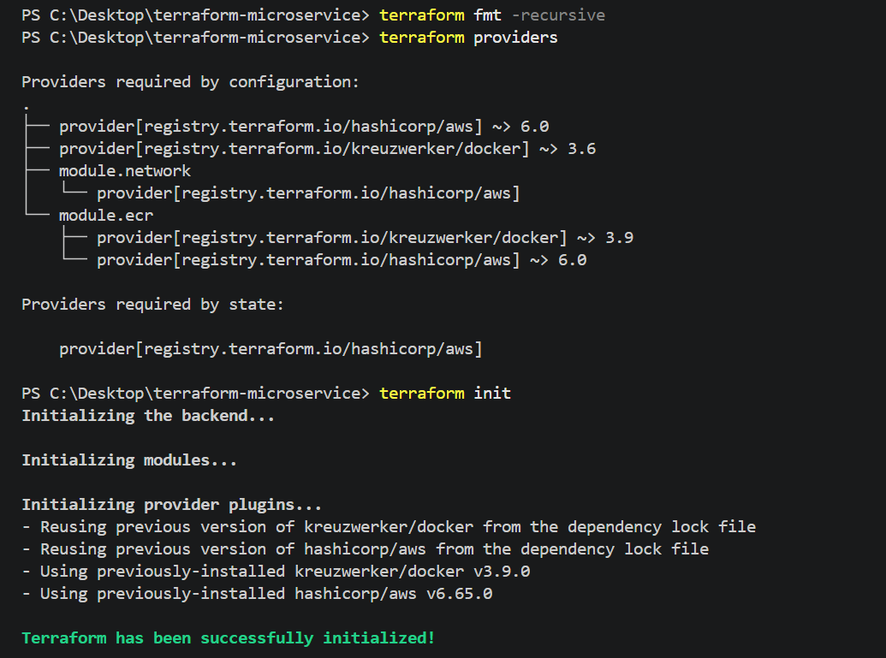

Step 40 — Verify your local Docker image
Before applying, make absolutely sure the image still exists: docker images terraform-microservice
You should see:
REPOSITORY TAG IMAGE ID
terraform-microservice latest xxxxxxxxxxxx
If it exists, continue.

Step 41 — Plan
Run: terraform plan
Terraform should now show resources including: module.ecr.aws_ecr_repository.this
module.ecr.aws_ecr_lifecycle_policy.this
module.ecr.docker_image.app
module.ecr.docker_registry_image.app
You should see the ECR repository already existing, so Terraform should not recreate it.
The important resource is: module.ecr.docker_registry_image.app
That's the resource that will push the image.
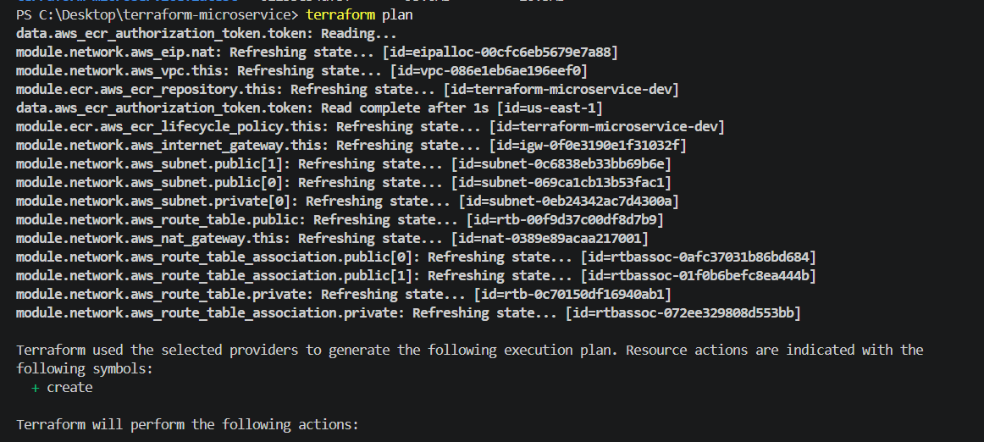

Step 42 — Apply
Run: terraform apply
Enter: yes
Watch the output carefully.
You should see something similar to:
module.ecr.docker_image.app: Creating...
module.ecr.docker_image.app: Creation complete
module.ecr.docker_registry_image.app: Creating...
module.ecr.docker_registry_image.app: Creation complete
The exact output may differ.
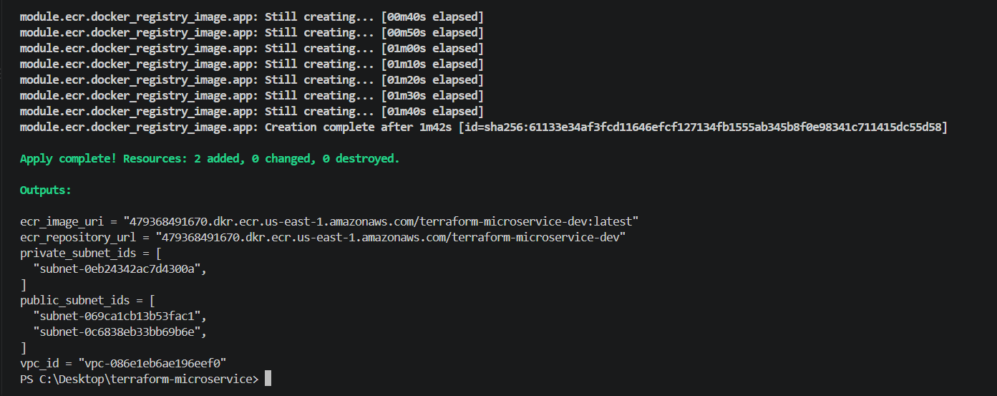
Step 43 — Verify the image in ECR
Run: aws ecr list-images `
--repository-name terraform-microservice-dev `
--region us-east-1
You should see an image with: latest
You can get the digest: aws ecr describe-images `
--repository-name terraform-microservice-dev `
--region us-east-1
You should see something similar to: imageTags: latest
imageDigest: sha256:xxxxxxxxxxxxxxxx
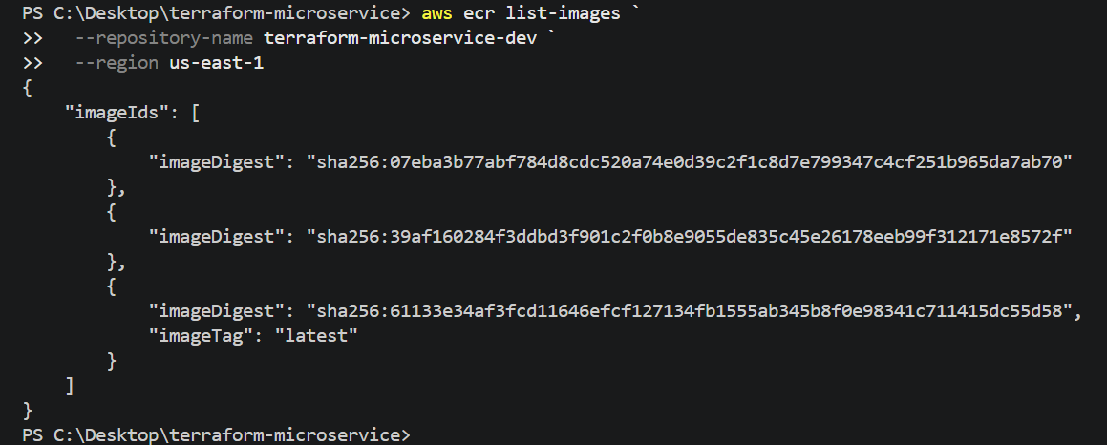

Step 44 — Verify Terraform output
Run: terraform output
You should now have something similar to:
ecr_image_uri = "123456789012.dkr.ecr.us-east-1.amazonaws.com/terraform-microservice-dev:latest"
ecr_repository_url = "123456789012.dkr.ecr.us-east-1.amazonaws.com/terraform-microservice-dev"
private_subnet_ids = [...]
public_subnet_ids = [...]
vpc_id = "vpc-xxxxxxxx"
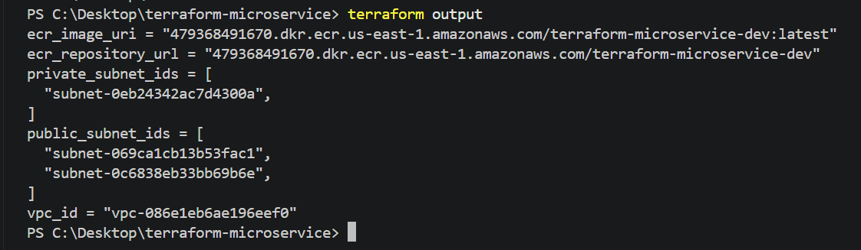
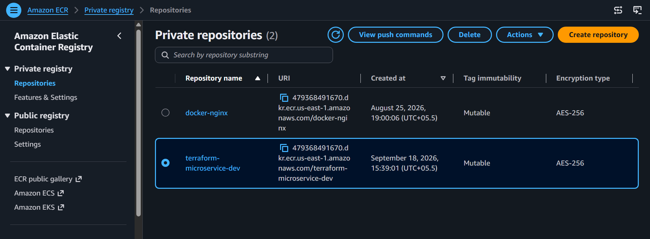

Why this satisfies the challenge
The requirement said: Build the image locally before running Terraform.
We did: docker build
↓
terraform-microservice:latest
Then: Once the image registry is created, use Terraform to push the local image.
We're doing:
docker_image.app
↓
docker_registry_image.app
↓
ECR
So we're not bypassing the exercise with a manual docker push.
Phase 4 — Security Groups and IAM
Our target traffic flow:
INTERNET
|
| HTTP :80
v
+------------------+
| Application LB |
| ALB-SG |
+--------+---------+
|
| HTTP :8080
v
+------------------+
| Ubuntu EC2 |
| EC2-SG |
| |
| Docker :8080 |
+------------------+
^
|
SSH :22 only
YOUR_IP/32
And ECR access will be:
EC2
|
| IAM Role
v
ECR
|
v
Pull Docker image
No ECR access keys will be stored on the EC2.

Step 45 — Create the security module
Create: modules\security\variables.tf
Add: variable "project_name" { description = "Project name"
type = string }
variable "environment" { description = "Environment name"
type = string }
variable "vpc_id" { description = "VPC ID"
type = string }
variable "allowed_ssh_cidr" { description = "CIDR allowed to SSH"
type = string }
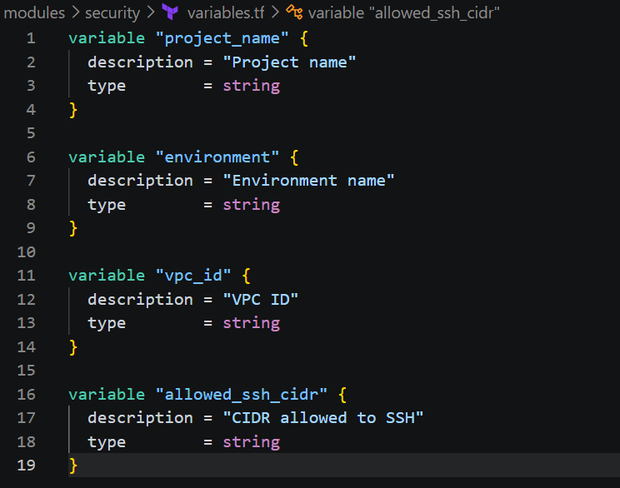
Step 46 — Security groups
Create:
modules\security\main.tf
Add: resource "aws_security_group" "alb" { name = "${var.project_name}-alb-sg"
description = "Security group for Application Load Balancer"
vpc_id = var.vpc_id
ingress { description = "HTTP from Internet"
protocol = "tcp"
from_port = 80
to_port = 80
cidr_blocks = ["0.0.0.0/0"] }
egress { description = "Allow all outbound traffic"
protocol = "-1"
from_port = 0
to_port = 0
cidr_blocks = ["0.0.0.0/0"]
}
tags = { Name = "${var.project_name}-alb-sg"
Environment = var.environment
}
}
resource "aws_security_group" "ec2" {
name = "${var.project_name}-ec2-sg"
description = "Security group for application EC2"
vpc_id = var.vpc_id
ingress { description = "HTTP from Application Load Balancer"
protocol = "tcp"
from_port = 8080
to_port = 8080
security_groups = [aws_security_group.alb.id] }
ingress { description = "SSH from approved IP"
protocol = "tcp"
from_port = 22
to_port = 22
cidr_blocks = [var.allowed_ssh_cidr] }
egress { description = "Allow all outbound traffic"
protocol = "-1"
from_port = 0
to_port = 0
cidr_blocks = ["0.0.0.0/0"] }
tags = { Name = "${var.project_name}-ec2-sg"
Environment = var.environment }
}
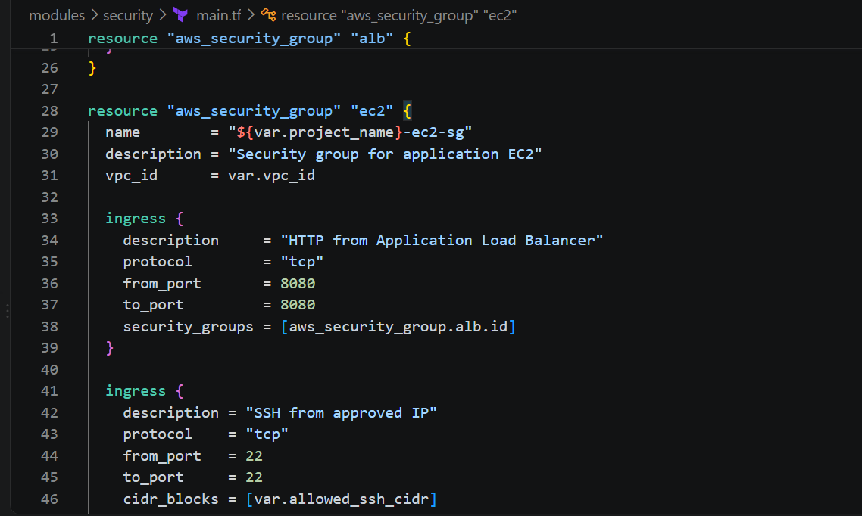
Step 47 — Why this security group is important
Notice that we didn't do this:
ingress { from_port = 8080
to_port = 8080
cidr_blocks = ["0.0.0.0/0"]
}
That would expose the application directly.
Instead: security_groups = [aws_security_group.alb.id]
means: Only resources using the ALB security group
can access EC2 port 8080.
Therefore:
Internet
|
X ---> EC2:8080
but:
Internet
|
v
ALB:80
|
v
EC2:8080
works.

Step 48 — Security outputs
Create: modules\security\outputs.tf
Add: output "alb_security_group_id" {
description = "ALB security group ID"
value = aws_security_group.alb.id }
output "ec2_security_group_id" {
description = "EC2 security group ID"
value = aws_security_group.ec2.id
}
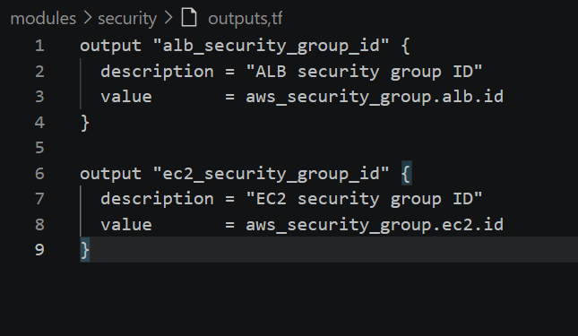
Step 49 — Add security module to root
Open: main.tf
Add after the ECR module:
module "security" {
source = "./modules/security"
project_name = var.project_name
environment = var.environment
vpc_id = module.network.vpc_id
allowed_ssh_cidr = var.allowed_ssh_cidr
}
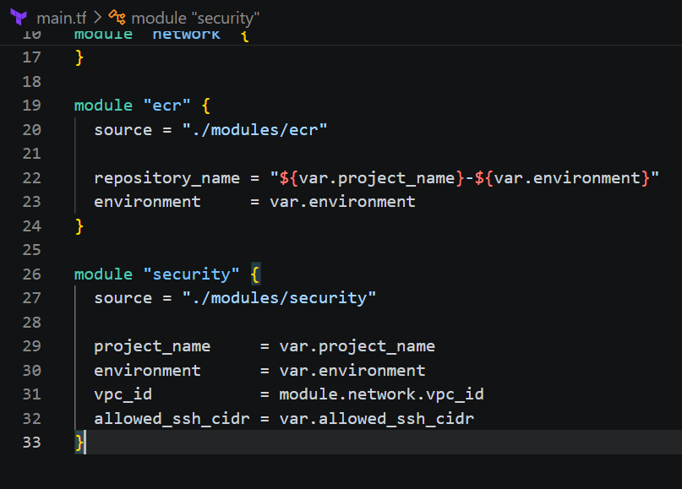
Your root architecture is now:
module.network
|
v
VPC
|
+------> module.security
|
+------> module.ecr

Step 50 — Create EC2 IAM role
The EC2 needs permission to pull from ECR.
We'll create the role in the compute module, because the role belongs to the application instance.
Create: modules\compute\variables.tf
Add: variable "project_name" {
description = "Project name"
type = string
}
variable "environment" {
description = "Environment name"
type = string
}
variable "vpc_id" {
description = "VPC ID"
type = string
}
variable "subnet_id" {
description = "Private subnet ID"
type = string
}
variable "security_group_id" {
description = "EC2 security group ID"
type = string
}
variable "instance_type" {
description = "EC2 instance type"
type = string
}
variable "ubuntu_ami" {
description = "Ubuntu AMI"
type = string
}

variable "key_name" {
description = "EC2 key pair name"
type = string
}
variable "public_key_path" {
description = "Public SSH key path"
type = string
}
variable "ecr_image_uri" {
description = "ECR image URI"
type = string
}
variable "aws_region" {
description = "AWS region"
type = string
}
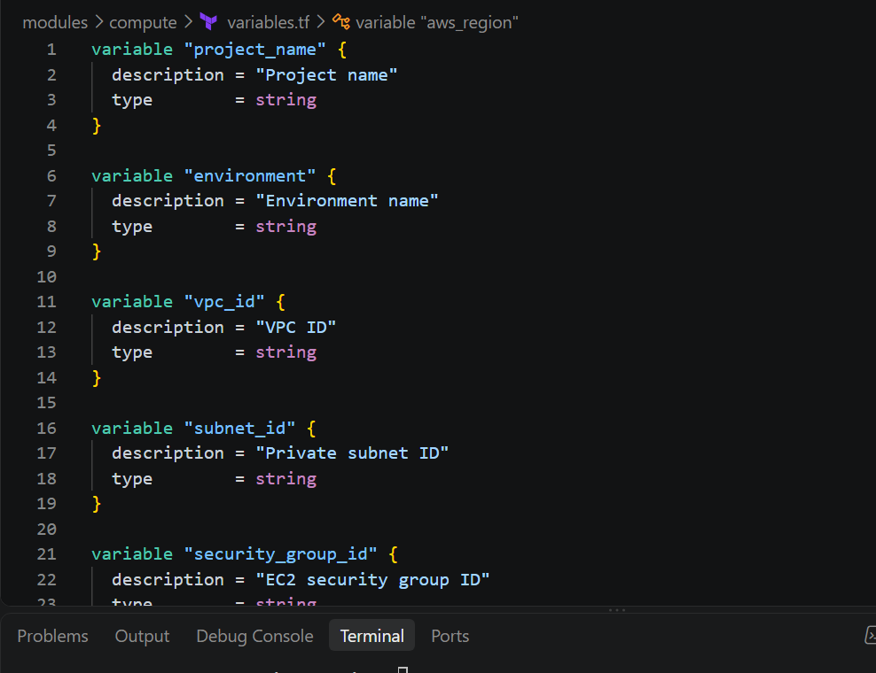

Step 51 — IAM role
Create: modules\compute\iam.tf
Add: resource "aws_iam_role" "ec2" {
name = "${var.project_name}-${var.environment}-ec2-role"
assume_role_policy = jsonencode({
Version = "2012-10-17"
Statement = [
{ Effect = "Allow"
Principal = {
Service = "ec2.amazonaws.com" }
Action = "sts:AssumeRole" }
]
})
tags = {
Name = "${var.project_name}-${var.environment}-ec2-role" Environment = var.environment
}
}
resource "aws_iam_role_policy_attachment" "ecr_read_only" {
role = aws_iam_role.ec2.name
policy_arn = "arn:aws:iam::aws:policy/AmazonEC2ContainerRegistryReadOnly"
}
resource "aws_iam_instance_profile" "ec2" {
name = "${var.project_name}-${var.environment}-instance-profile"
role = aws_iam_role.ec2.name
}
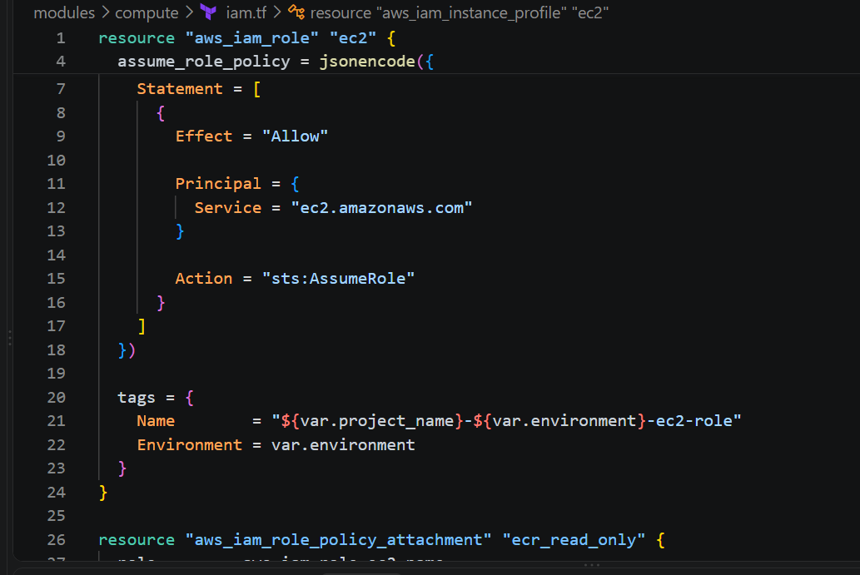

Step 52 — Why we're using an IAM role
We don't want this on the server: AWS_ACCESS_KEY_ID=...
AWS_SECRET_ACCESS_KEY=...
Instead:
EC2
|
v
Instance Profile
|
v
IAM Role
|
v
AmazonEC2ContainerRegistryReadOnly
|
v
ECR
The EC2 can therefore authenticate to ECR using AWS's instance metadata credentials.

Step 53 — SSH key resource
The requirement says:
Use a locally created key and add it to cloud provider key storage.
We'll have Terraform create the AWS key pair from your local public key.
Create: modules\compute\keypair.tf
Add: resource "aws_key_pair" "this" {
key_name = var.key_name
public_key = file(var.public_key_path)
tags = {
Name = var.key_name
Environment = var.environment
}
}
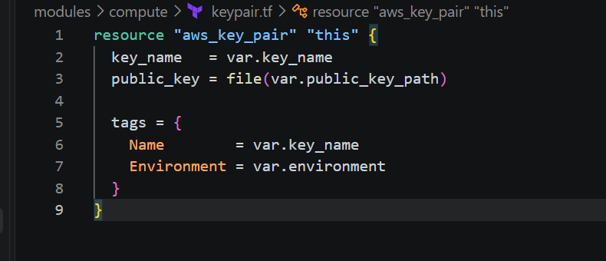
So the flow is:
Windows
|
| terraform reads
v
terraform-microservice.pub
|
v
AWS EC2 Key Pair
The private key never gets uploaded to AWS.

Step 54 — Create EC2 main.tf
Create: modules\compute\main.tf
For now add: resource "aws_instance" "this" {
ami = var.ubuntu_ami
instance_type = var.instance_type
subnet_id = var.subnet_id
vpc_security_group_ids = [var.security_group_id]
key_name = aws_key_pair.this.key_name
iam_instance_profile = aws_iam_instance_profile.ec2.name
associate_public_ip_address = false
user_data = templatefile("${path.module}/../../scripts/user-data.sh", {
aws_region = var.aws_region
ecr_image_uri = var.ecr_image_uri
})
user_data_replace_on_change = true
root_block_device {
volume_size = 8
volume_type = "gp3"
encrypted = true
}
tags = {
Name = "${var.project_name}-${var.environment}-app"
Environment = var.environment
Role = "application"
}
}
Important
This: associate_public_ip_address = false
is intentional.
The EC2 will be private.
It will not receive a public IPv4 address.
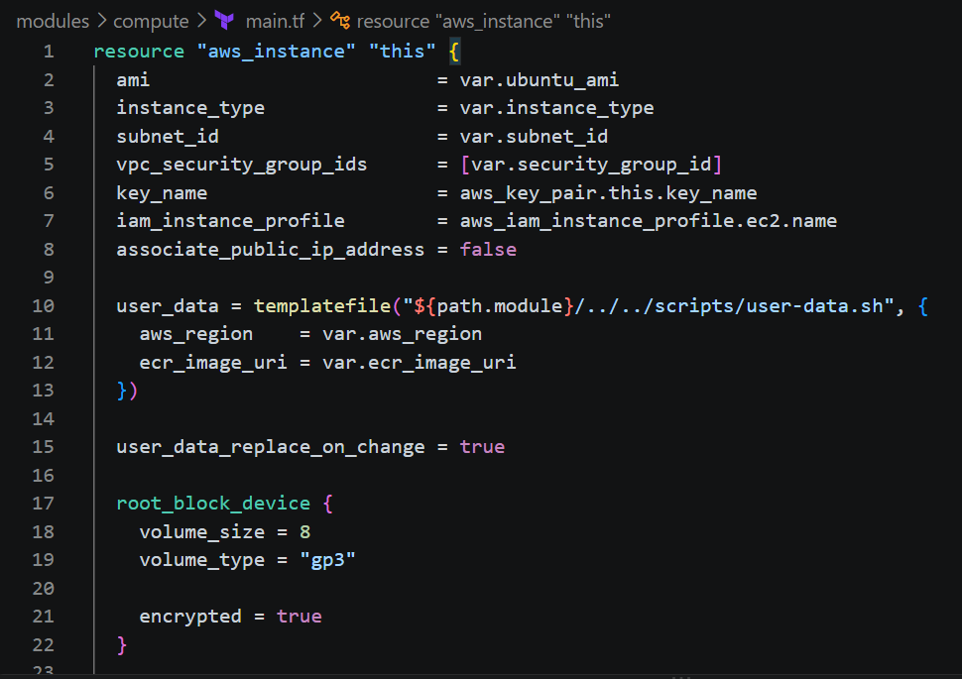

Step 55 — Create EC2 outputs
Create: modules\compute\outputs.tf
Add: output "instance_id" {
description = "EC2 instance ID"
value = aws_instance.this.id
}
output "private_ip" {
description = "Private IP address"
value = aws_instance.this.private_ip
}
output "instance_arn" {
description = "EC2 instance ARN"
value = aws_instance.this.arn
}
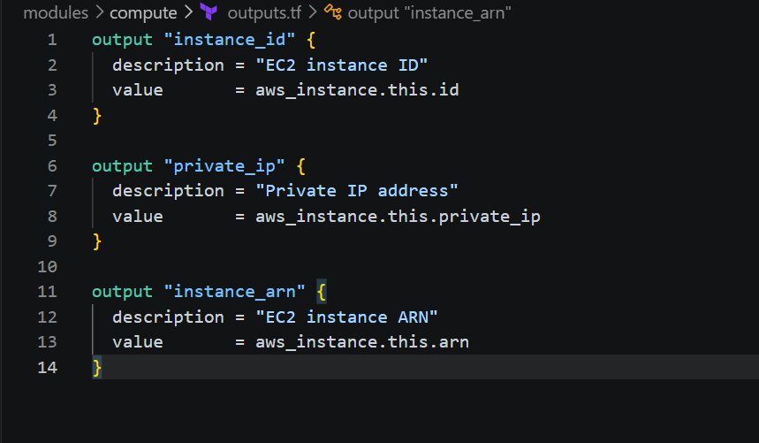
Validate the security layer now
Run: terraform fmt -recursive
Then: terraform validate
Then: terraform plan
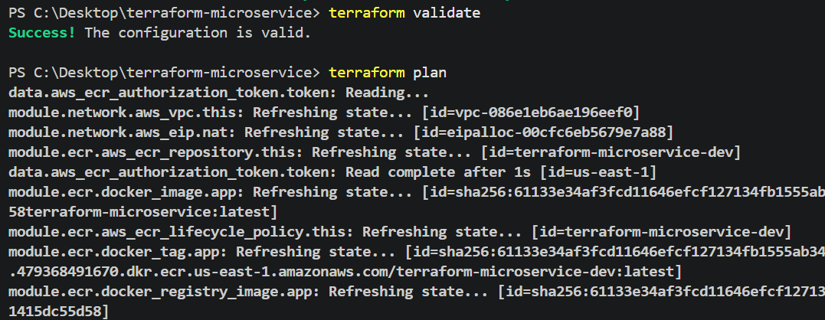
Now we create the EC2 bootstrap script. This is the piece that connects ECR → private EC2 → Docker container.
Phase 5 — Deploy Docker Container on Private EC2
Final flow:
AWS
|
+--------+--------+
| ECR |
| private image |
+--------+-------+
|
| pull
|
Private subnet
|
+------+------+
| Ubuntu EC2 |
| |
| Docker |
| ↓ |
| nginx |
| :8080 |
+------------+
The EC2 will have:
- No public IP
- Docker installed automatically
- ECR authentication through IAM role
- Docker image pulled from ECR
- Container listening on port 8080

Step 57 — Create user-data.sh
Create:
scripts\user-data.sh
Put this inside:
#!/bin/bash
set -euxo pipefail
exec > >(tee /var/log/terraform-user-data.log | logger -t terraform-user-data -s 2>/dev/console) 2>&1
echo "Starting application server bootstrap..."
export DEBIAN_FRONTEND=noninteractive
apt-get update -y
apt-get install -y \ docker.io \ awscli
systemctl enable docker
systemctl start docker
usermod -aG docker ubuntu
echo "Docker version:"
docker --version
echo "AWS CLI version:"
aws --version
echo "Logging into Amazon ECR..."
aws ecr get-login-password \
--region ${aws_region} \
| docker login \
--username AWS \
--password-stdin \
$(echo "${ecr_image_uri}" | cut -d/ -f1)
echo "Pulling application image..."
docker pull "${ecr_image_uri}"
echo "Starting application container..."
docker rm -f terraform-microservice 2>/dev/null || true
docker run -d \
--name terraform-microservice \
--restart unless-stopped \
-p 8080:8080 \
"${ecr_image_uri}"
echo "Container status:"
docker ps
echo "Bootstrap completed successfully."
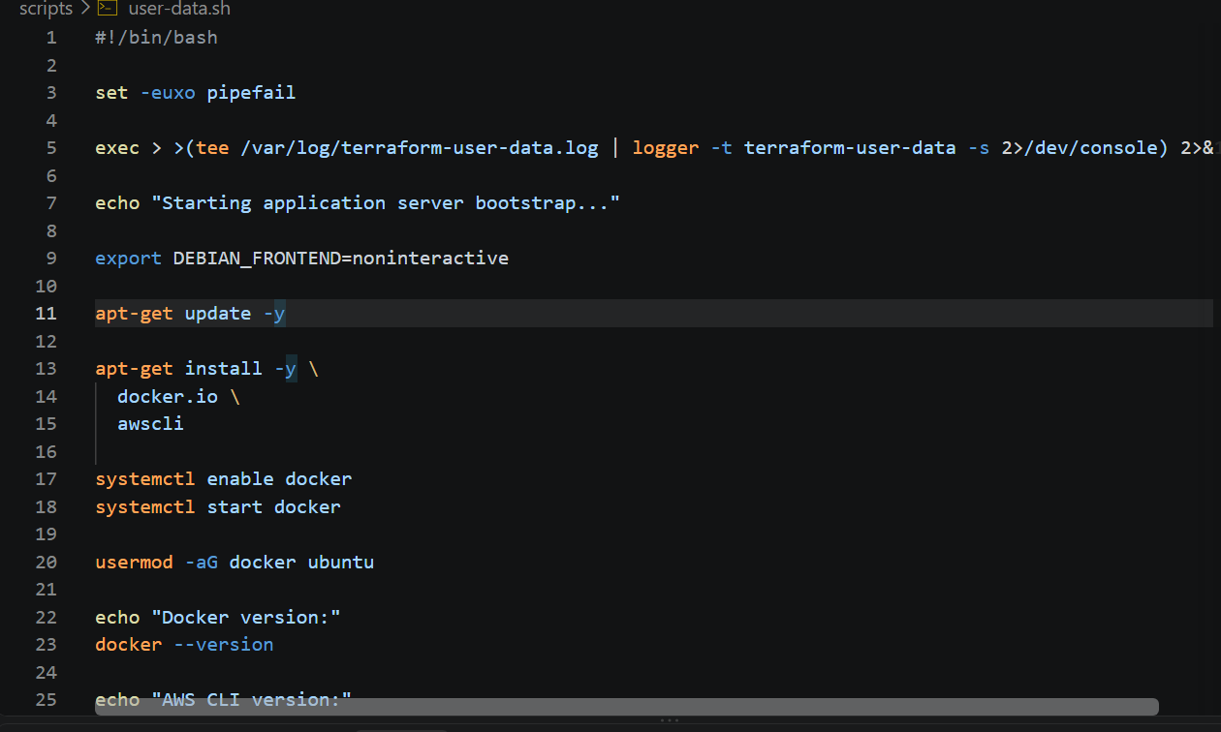

Step 58 — Understand the ECR login
This section:
aws ecr get-login-password \
--region ${aws_region} \
| docker login \
--username AWS \
--password-stdin \
$(echo "${ecr_image_uri}" | cut -d/ -f1)
uses the EC2 IAM role.
The EC2 doesn't have static AWS credentials.
Instead:
EC2
|
| Instance Profile
v
IAM Role
|
| AmazonEC2ContainerRegistryReadOnly
v
ECR
That's the secure approach.

Step 59 — Important dependency: NAT Gateway
Remember our networking design:
Private EC2
|
v
Private Route Table
|
v
NAT Gateway
|
v
Internet Gateway
|
v
Internet
The NAT Gateway allows the private EC2 to reach:
Ubuntu repositories
Docker packages
AWS ECR
while preventing unsolicited inbound Internet connections.

Step 60 — Add compute module to root
Open: main.tf
Add:
module "compute" {
source = "./modules/compute"

project_name = var.project_name
environment = var.environment
vpc_id = module.network.vpc_id
subnet_id = module.network.private_subnet_ids[0]
security_group_id = module.security.ec2_security_group_id
instance_type = var.instance_type
ubuntu_ami = var.ubuntu_ami
key_name = var.key_name
public_key_path = var.public_key_path
ecr_image_uri = module.ecr.image_uri
aws_region = var.aws_region
}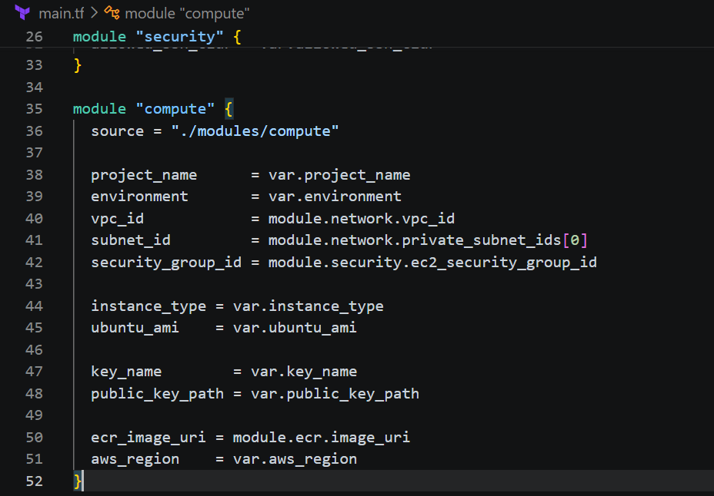
Your root main.tf should now contain these four modules:
module.network
module.ecr
module.security
module.computeStep 61 — Add EC2 outputs to root
Open: outputs.tf
Add: output "ec2_instance_id" {
description = "Application EC2 instance ID"
value = module.compute.instance_id
}
output "ec2_private_ip" {
description = "Application EC2 private IP"
value = module.compute.private_ip
}
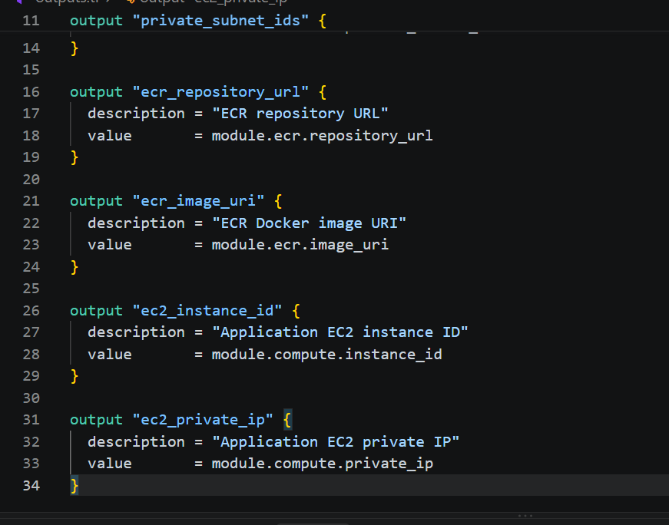Step 62 — Format everything
Run: terraform fmt -recursive
Then: terraform validate
Expected: Success! The configuration is valid.
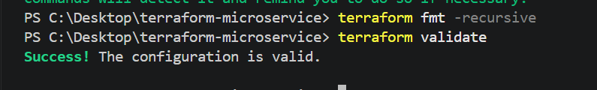
Step 63 — Plan the EC2
Run: terraform plan
Now Terraform should show the complete infrastructure we've built so far.
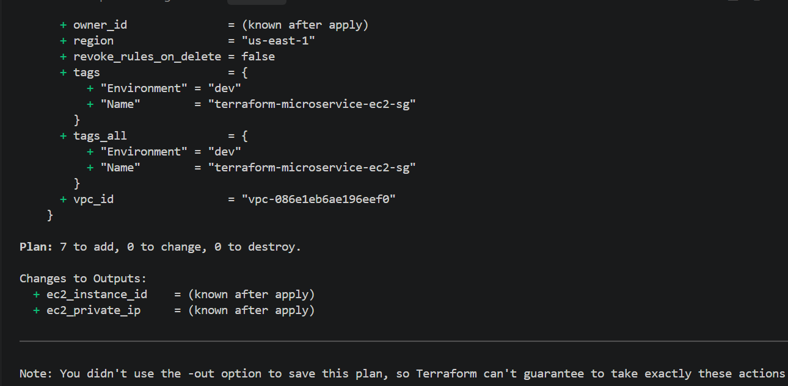
You should see resources corresponding to:
VPC
├── Internet Gateway
├── Public Subnet A
├── Public Subnet B
├── Private Subnet
├── Public Route Table
├── Private Route Table
├── NAT Gateway
└── Elastic IP
ECR
├── Repository
└── Lifecycle Policy
Security
├── ALB Security Group
└── EC2 Security Group
IAM
├── EC2 Role
├── ECR ReadOnly Policy
└── Instance Profile
EC2
├── Key Pair
└── Ubuntu InstanceStep 64 — One important check before apply
Open: terraform.tfvars
Verify these carefully:aws_region = "us-east-1"
key_name = "terraform-microservice-key"
public_key_path = "C:/Users/YOUR_USERNAME/.ssh/terraform-microservice.pub"
ubuntu_ami = "ami-0b6d9d3d33ba97d99"
allowed_ssh_cidr = "YOUR_PUBLIC_IP/32"
Verify the public key exists
Run: Test-Path $HOME\.ssh\terraform-microservice.pub
Expected: True
Verify the private key exists
Test-Path $HOME\.ssh\terraform-microservice
Expected: True 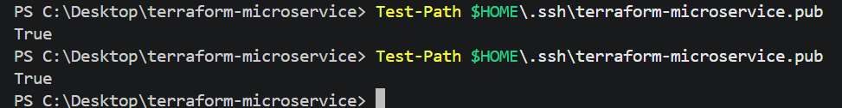Step 65 — Verify the AMI
Because AMI IDs are region-specific, let's verify that the AMI you're using actually exists in us-east-1.
Run: aws ec2 describe-images `
--region us-east-1 `
--image-ids ami-0b6d9d3d33ba97d99 `
--query "Images[0].[ImageId,Name,State]" `
--output table
If it returns the image, we're good.
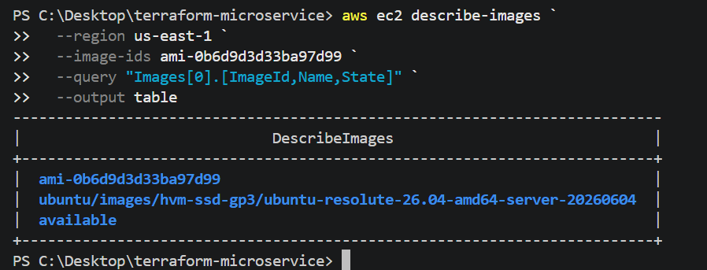
If AWS says the image doesn't exist, don't apply. Send me the output and we'll select a current Ubuntu AMI for us-east-1.

Step 66 — Apply the infrastructure
Once: terraform validate → Success
AMI check → successful
terraform plan → successful
run: terraform apply
Enter: yes
Terraform will create the private EC2.
The important part is: associate_public_ip_address = false
Therefore the EC2 will not have a public IPv4 address.
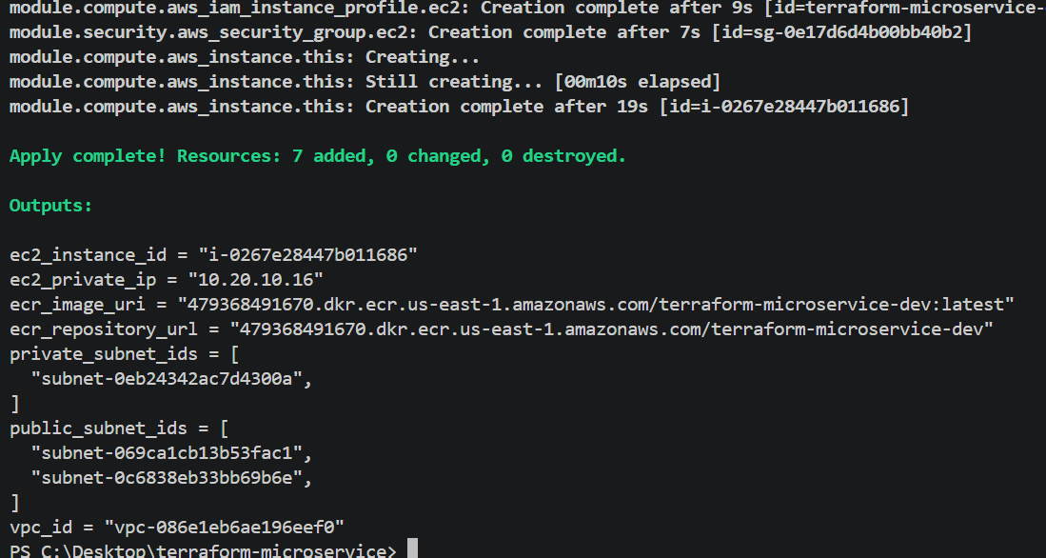
Step 67 — Wait for user-data
After Terraform finishes, don't immediately assume Docker is ready.
The EC2 needs to run:
apt update
↓
install docker.io
↓
install awscli
↓
start Docker
↓
ECR login
↓
docker pull
↓
docker run
We will verify that before creating the ALB.

Step 68 — Get the EC2 private IP
Run: terraform output ec2_private_ip
Example: "10.20.10.123"
This is exactly what we want.
There should be no public IP.
Step 69 — Verify EC2 from AWS CLI
Run: aws ec2 describe-instances `
--region us-east-1 `
--filters "Name=tag:Name,Values=terraform-microservice-dev-app" `
--query "Reservations[].Instances[].[InstanceId,PrivateIpAddress,PublicIpAddress,State.Name]" `
--output table
Expected conceptually:
------------------------------------------------
| InstanceId | Private IP | Public IP | State |
------------------------------------------------
| i-xxxxx | 10.20.10.x | None | running
------------------------------------------------
The Public IP should be None.
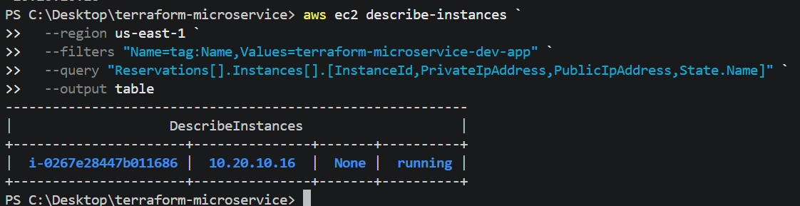

Step 70 — Important: Don't try normal SSH yet
Because the EC2 is private:
Your laptop
|
X
|
Private EC2
you cannot directly do:
ssh ubuntu@10.20.10.x
from your laptop over the Internet.
That is intentional.
For the challenge, the EC2 should only be accessible from the Internet through the Load Balancer, with SSH restricted to approved IP addresses. Because the instance is private, we will need a suitable management path if we want to SSH directly—for example, a bastion or AWS Systems Manager.
We already have an IAM role for ECR, but we haven't added SSM permissions, so don't attempt SSM yet.
For now, we'll validate the bootstrap through AWS/EC2 mechanisms and then build the ALB.

Step 71 — Check EC2 system status
Run: aws ec2 describe-instance-status `
--region us-east-1 `
--instance-ids $(terraform output -raw ec2_instance_id) `
--include-all-instances `
--query "InstanceStatuses[0].[InstanceState.Name,SystemStatus.Status,InstanceStatus.Status]" `
--output table
We want:
running
ok
ok
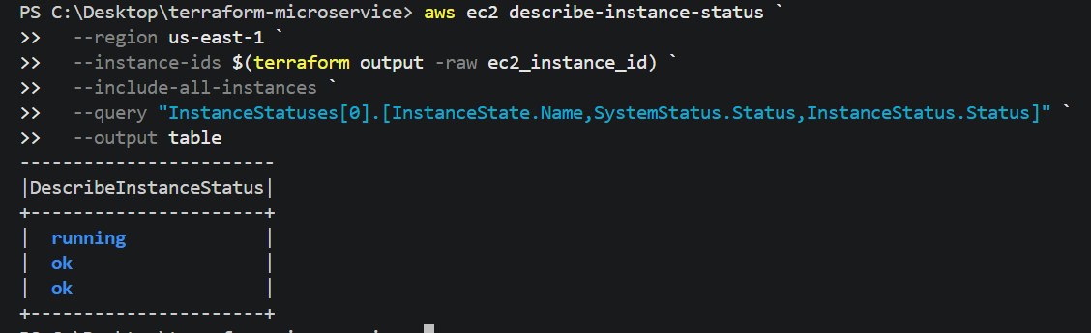
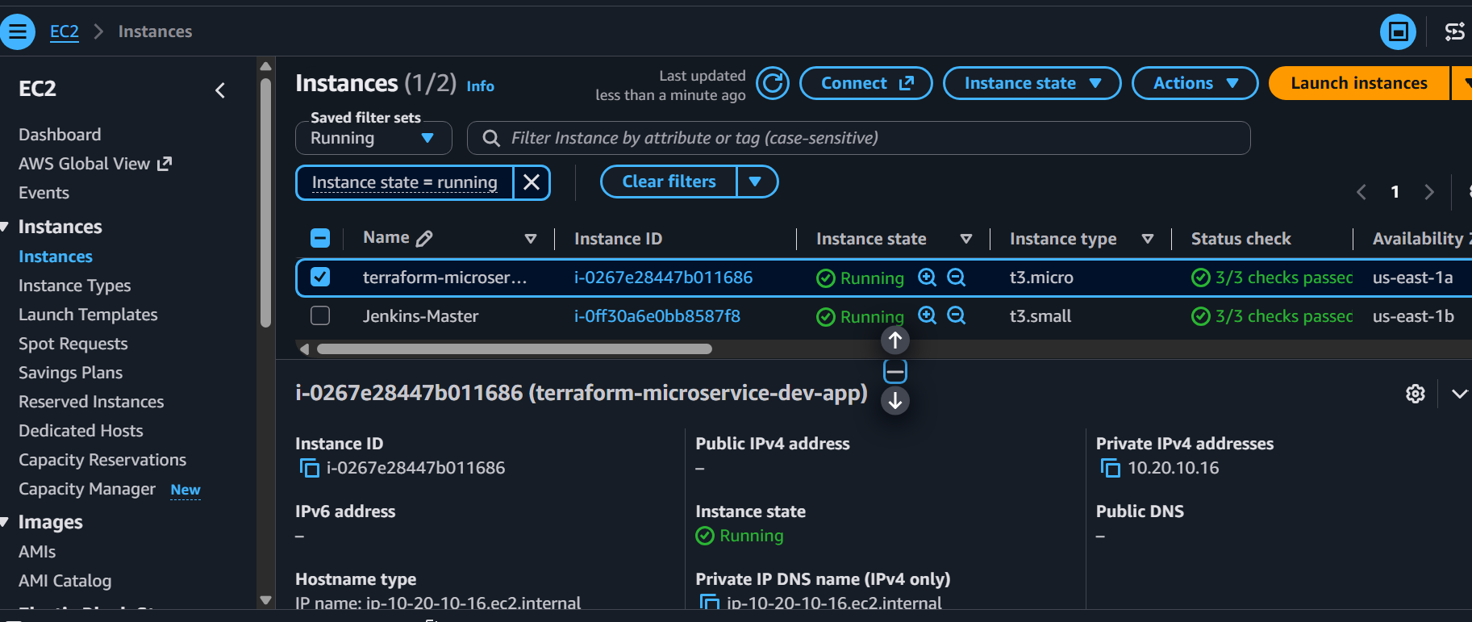

Now we'll create the Application Load Balancer.
Phase 6 — Application Load Balancer
Target architecture:
INTERNET
|
TCP :80
|
v
+---------------------+
| Application |
| Load Balancer |
| |
| Public Subnet A |
| Public Subnet B |
+----------+----------+
|
HTTP :8080
|
v
+---------------------+
| Target Group |
| HTTP :8080 |
+----------+----------+
|
v
+---------------------+
| Private Ubuntu EC2 |
| |
| Docker |
| nginx :8080 |
+---------------------+
The important security property remains:
Internet ---> EC2:8080 ❌
Internet ---> EC2:22 ❌ except approved IP
Internet ---> ALB:80 ✅
ALB -------> EC2:8080 ✅
Step 72 — Create the ALB module variables
Create: modules\alb\variables.tf
Add: variable "project_name" { description = "Project name"
type = string}
variable "environment" { description = "Environment name"
type = string }
variable "vpc_id" { description = "VPC ID"
type = string }
variable "public_subnet_ids" { description = "Public subnet IDs"
type = list(string) }
variable "security_group_id" { description = "ALB security group ID"
type = string }
variable "instance_id" {
description = "Application EC2 instance ID"
type = string
}
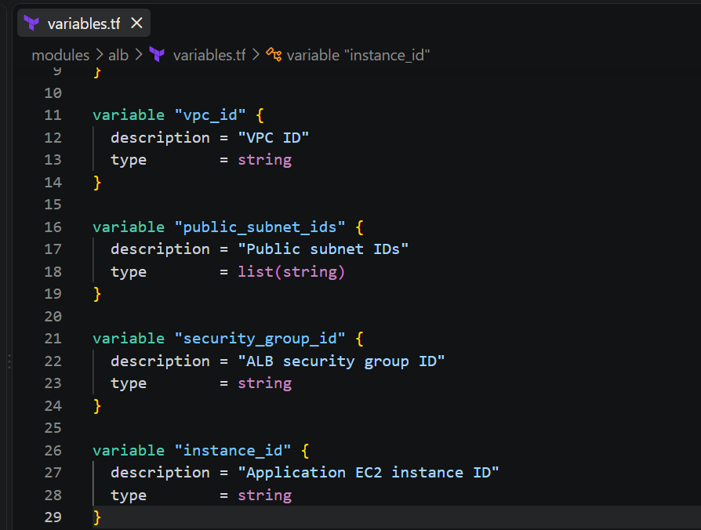

Step 73 — Create the ALB
Create: modules\alb\main.tf
Add: resource "aws_lb" "this" {
name = "${var.project_name}-${var.environment}-alb"
internal = false
load_balancer_type = "application"
security_groups = [
var.security_group_id
]
subnets = var.public_subnet_ids
enable_deletion_protection = false
tags = { Name = "${var.project_name}-${var.environment}-alb"
Environment = var.environment
}
}
The important setting is: internal = false
This makes the ALB internet-facing.
The EC2 remains private.
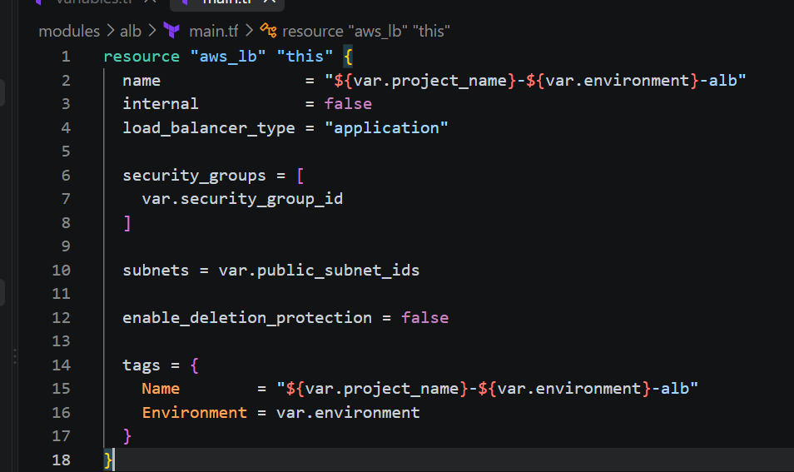

Step 74 — Create the target group
Add to the same: modules\alb\main.tf
resource "aws_lb_target_group" "app" {
name = "${var.project_name}-${var.environment}-tg"
port = 8080
protocol = "HTTP"
target_type = "instance"
vpc_id = var.vpc_id
health_check {
enabled = true
protocol = "HTTP"
path = "/"
port = "8080"
healthy_threshold = 2
unhealthy_threshold = 3
timeout = 5
interval = 30
matcher = "200"
}
tags = {
Name = "${var.project_name}-${var.environment}-tg"
Environment = var.environment
}
}
This tells AWS: Target: EC2
Protocol: HTTP
Port: 8080
Health check:
/
Expected: HTTP 200
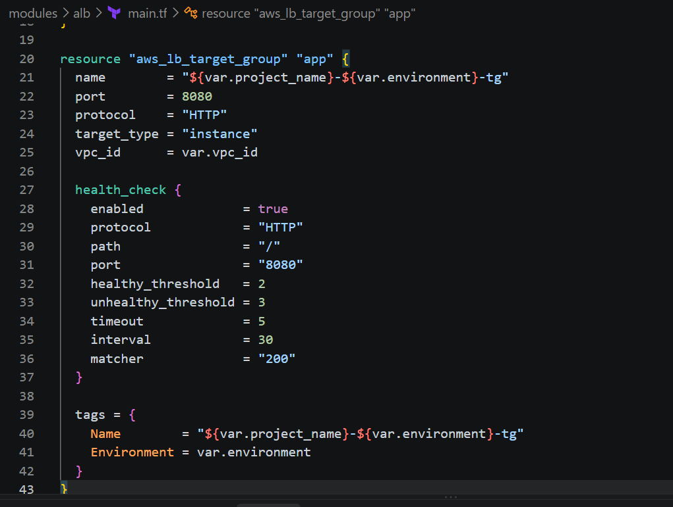

Step 75 — Register EC2 with target group
Add:
resource "aws_lb_target_group_attachment" "app" {
target_group_arn = aws_lb_target_group.app.arn
target_id = var.instance_id
port = 8080
}
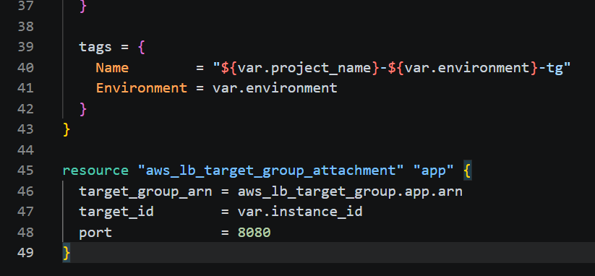
So:
ALB
|
v
Target Group
|
v
EC2 private IP :8080

Step 76 — Create HTTP listener
Add: resource "aws_lb_listener" "http" {
load_balancer_arn = aws_lb.this.arn
port = 80
protocol = "HTTP"
default_action {
type = "forward"
forward {
target_group {
arn = aws_lb_target_group.app.arn
}
}
}
}
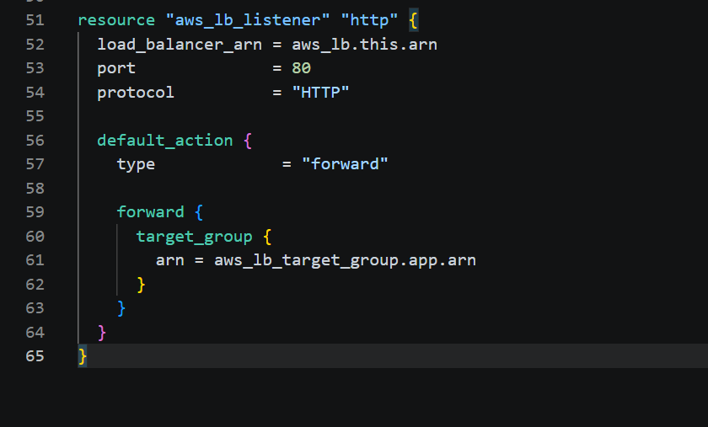
Now:
http://ALB-DNS/
|
v
ALB :80
|
v
Target Group :8080
|
v
EC2

Step 77 — ALB outputs
Create: modules\alb\outputs.tf
Add: output "load_balancer_id" {
description = "Application Load Balancer ID"
value = aws_lb.this.id
}
output "load_balancer_arn" {
description = "Application Load Balancer ARN"
value = aws_lb.this.arn
}
output "dns_name" {
description = "Application Load Balancer DNS name"
value = aws_lb.this.dns_name
}
output "target_group_arn" {
description = "Target group ARN"
value = aws_lb_target_group.app.arn
}
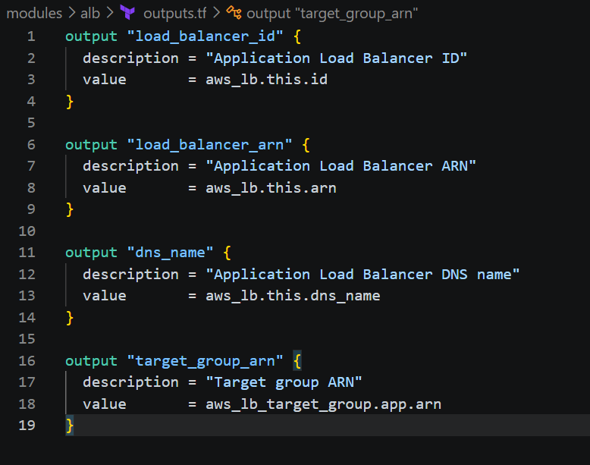

Step 78 — Add ALB module to root
Open: main.tf
Add: module "alb" {
source = "./modules/alb"
project_name = var.project_name
environment = var.environment
vpc_id = module.network.vpc_id
public_subnet_ids = module.network.public_subnet_ids
security_group_id = module.security.alb_security_group_id
instance_id = module.compute.instance_id
}
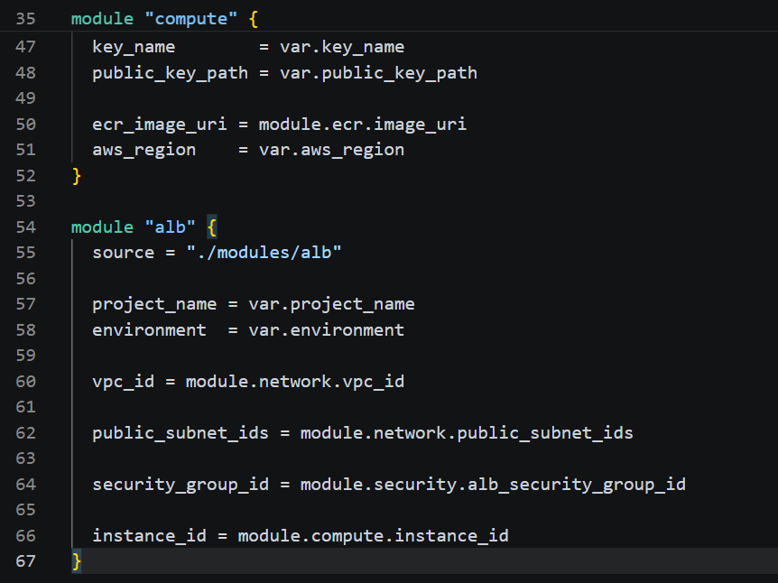
Your architecture now becomes:
module.network
|
+----------------+
| |
v v
module.security module.compute
| |
| |
+-------> module.alb

Step 79 — Add ALB output to root
Open: outputs.tf
Add: output "alb_dns_name" {
description = "Application Load Balancer DNS name"
value = module.alb.dns_name
}
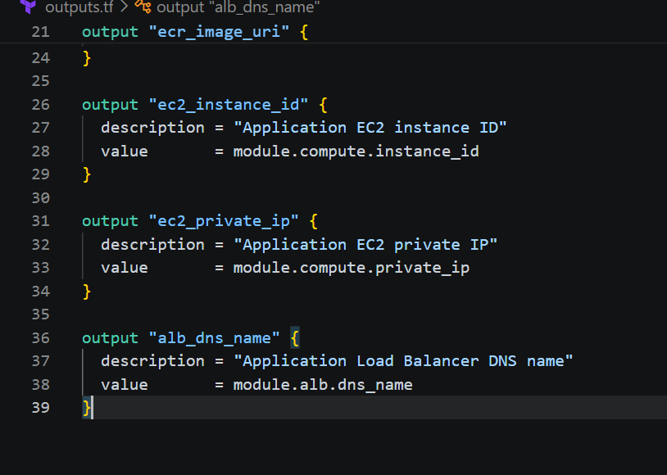Step 80 — Format
Run: terraform fmt -recursive
Then: terraform validate
Expected: Success! The configuration is valid.
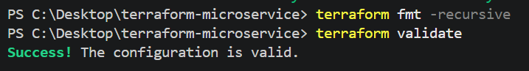
Step 81 — Plan
Run: terraform plan
You should see new resources similar to:
module.alb.aws_lb.this
module.alb.aws_lb_target_group.app
module.alb.aws_lb_target_group_attachment.app
module.alb.aws_lb_listener.http
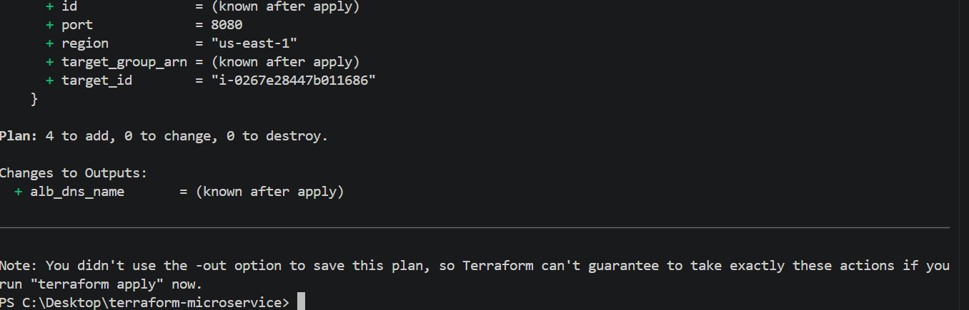
Step 82 — Apply
Now run: terraform apply
Enter: yes
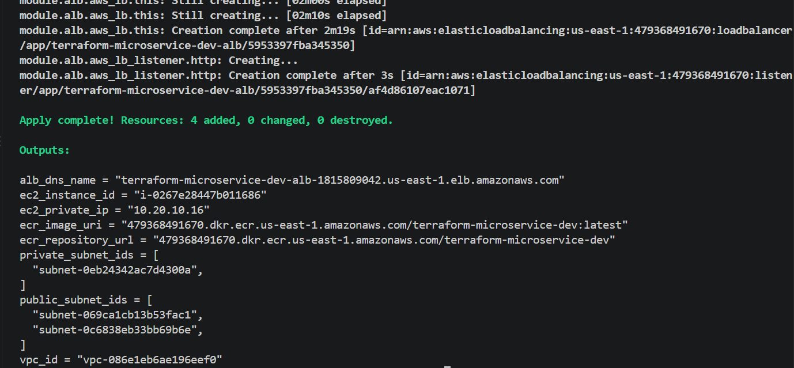
Terraform will create:
Internet-facing ALB
|
v
Target Group
|
v
Private EC2

Step 83 — Get the ALB DNS name
After apply: terraform output alb_dns_name
You should get something similar to:
terraform-microservice-dev-alb-123456789.us-east-1.elb.amazonaws.com
Now test: curl http://$(terraform output -raw alb_dns_name)
Or open the returned DNS name in your browser.
You should see:
Hello from Terraform!
This application is running inside an Nginx Docker container on AWS EC2.
Traffic is received through an Application Load Balancer.
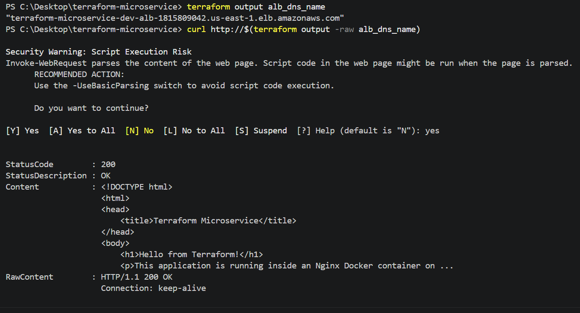
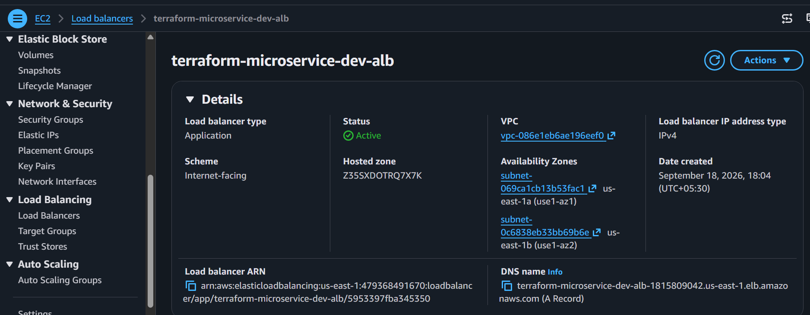

Step 84 — Check target health
This is very important.
Run: aws elbv2 describe-target-health `
--region us-east-1 `
--target-group-arn $(terraform output -raw target_group_arn)
You want: State: healthy
The target health should eventually become: healthy
It can take a short time after the instance/container starts.
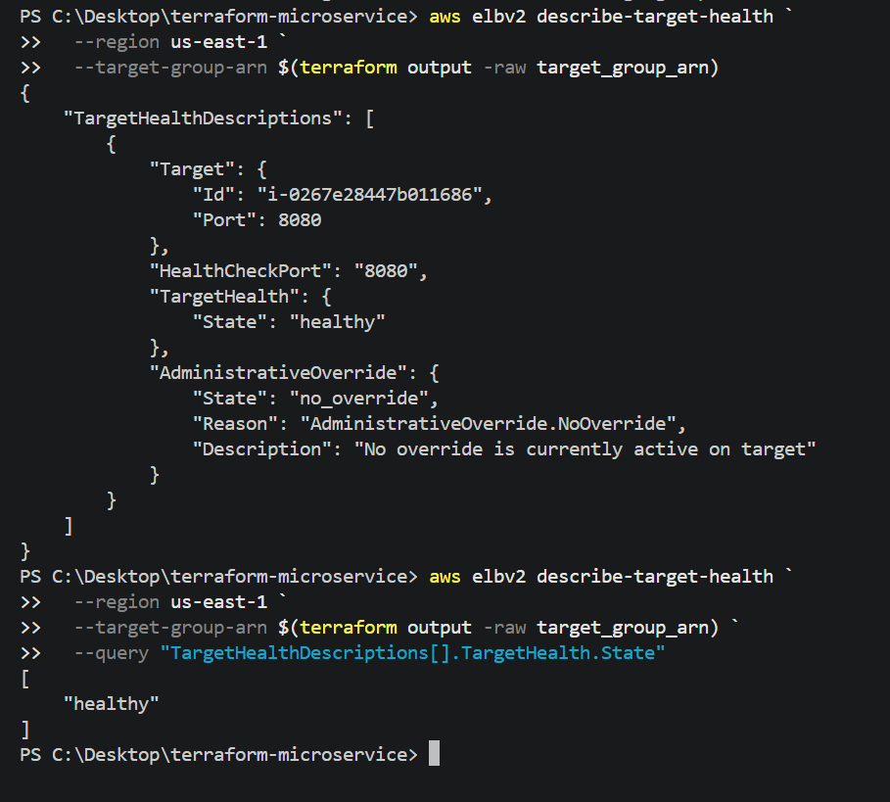
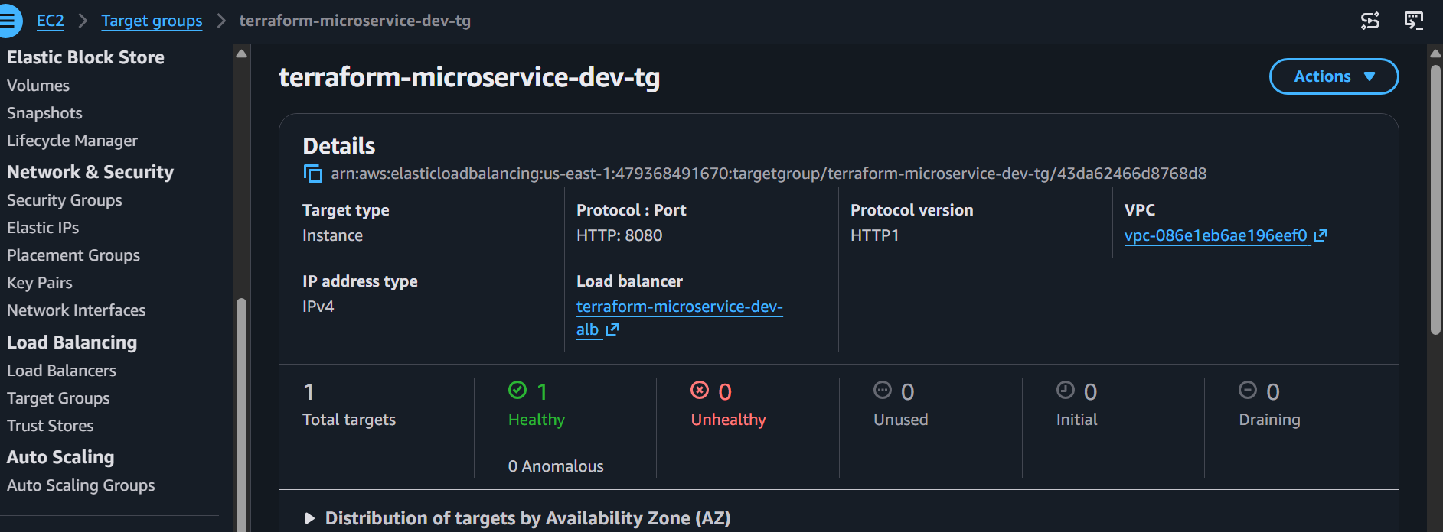
Terraform Challenge Complete
You have now implemented the requested architecture:
INTERNET
|
| HTTP :80
v
+----------------------+
| Application Load |
| Balancer |
| Public Subnets |
+----------+-----------+
|
| HTTP :8080
v
+----------------------+
| Private EC2 |
| 10.20.10.16 |
| No Public IP |
| |
| Docker |
| └── Nginx :8080 |
+----------+-----------+
|
| Pull image
v
+----------------------+
| Amazon ECR |
| terraform- |
| microservice-dev |
+----------------------+

